**Welcome to the 6th edition of Lothian AHP Practice Education newsletter!**

You can access this and older editions via the [AHP Practice Education](http://intranet.lothian.scot.nhs.uk/HR/About/ourservices/EducationandEmployeeDevelopment/staffdevelopment/AHP/Pages/AHPPracticeEducation.aspx) pages on the intranet.

Please drop in and have a look for more information on the recovery and remobilisation of student placement and also the importance of effective support and supervision for AHP staff and teams at this time.

Within this edition of the newsletter you will find information on:

|  |  |
| --- | --- |
| **Page Number** | **Topic** |
| 2 | Toolkit Update |
| 2 | QMU Practice Educator Sessions |
| 2 | NES ‘How To... Support a Student at Risk of Failing on Placement’ Workshop |
| 3 – 4 | Student Placement Updates |
| 4 | Communication Channels |
| 5 | Team Updates |
| 5 | Contact Us |

**For Staff and Students**

**6th Edition – February 2022**

**LOTHIAN AHP PRACTICE PLACEMENTS NEWSLETTER**

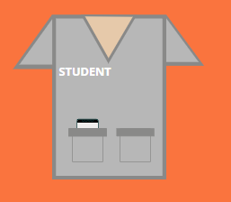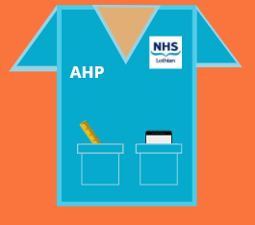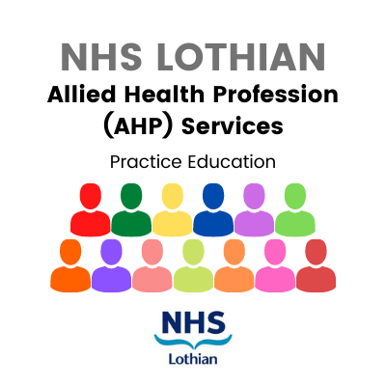



**TOOLKIT UPDATE**

There have been some additions and changes made to the [**AHP Student Placement Planning Toolkit**](https://scottish.sharepoint.com/:w:/s/AHPStudentPlacementPlanningToolkit-Launch08.07.2021/ESqxXsjmDw1IgpeeJ0sKJCYBiKx_pOkNn4s7k_fHVFYP8A?e=TMi8t5). Please make sure to access the toolkit via the intranet page to make sure you’re seeing the most up to date information. As always, let us know if there is anything you think is missing and we’ll get on the case!

**Our tookit is now mobile friendly – scan the QR code for access!**

**QMU PRACTICE EDUCATOR SESSIONS**

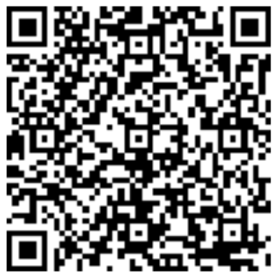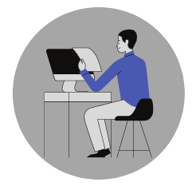

NES are running a 'How to...' workshop on this topic on 3rd March as advertised previously. Registration is now closed but a recording will be made available on the NES website in the near future. **Please also see the QMU Practice Educator session advertised above which covers this topic.**

Supporting a student who is at risk of failing placement is difficult and some practice educators do not feel confident having conversations around this topic or know how best to support these students. We always emphasise the importance of collaborating with the university from the earliest opportunity when it’s necessary to discuss performance concerns.

Although there are lots of ways to support a student to improve their performance if they are struggling, it’s also important to recognise that sometimes the best development opportunity for them is to be able to repeat a placement. The universities have emphasised they don’t want practice educators to be afraid of the ‘F’ word but also that there are processes and good practice advice to follow in these situations.

We have also developed an[**AHP Placement Process poster**](https://scottish.sharepoint.com/:b:/s/AHPStudentPlacementPlanningToolkit-Launch08.07.2021/EQDLCgSQ1kFFgA0MOEMXiw4Btu4_kR2kDSVgOJgssWztWA?e=Yna2yo) with links to some relevant information for planning student placements.

**NES ‘HOW TO... SUPPORT A STUDENT AT RISK OF FAILING ON PLACEMENT’ WORKSHOP**

QMU have set up a range of Practice Education Training Workshops on important topics such as reasonable adjustments, supporting a failing student, equality and diversity and providing feedback.

**See the** [**advert**](https://scottish.sharepoint.com/:b:/s/AHPPELLunchandLearn/EV78Jn0hYjBLuUYKgTkghp0BxOpVri9M2KB7IW6ZmFea7w?e=ToiIPo) **which includes sign up information.**



be used to support the development of clinical skills including both technical skills (e.g. clinical examination, treatment techniques) and non-technical skills (e.g. decision making, team work, communication).

New resources and opportunities in relation to simulation based education for AHPs will hopefully be available in the near future. However, **if you already have experience in this area with either students or staff, we’d love to hear about it so please get in touch!**

**IT UPDATE**

**STUDENT PLACEMENT UPDATES**

We have received some **positive feedback** about IT account access being quicker and smoother for Semester 2 students which we’re delighted to hear. However let us know if this hasn’t been the case for your student and they are experiencing delays.

There are ongoing discussions about a **change to the process of applying for student accounts** and we will keep you up to date about when this comes into action.

**Hospital Electronic Prescribing and Medicines Administration (HEPMA)** is up and running in some sites. This may mean it’s a system that your student needs access to if they need to see what medication a patient is on. **Read only** access for students can be requested if needed.

**JISC FEEDBACK**

Thanks to those of you who have asked your student to fill in the placement survey! Please continue to ask students to do it at the end of their placement so we can continually improve our processes. The QR code and link is in the toolkit, on the Induction Checklist and it’s also here:

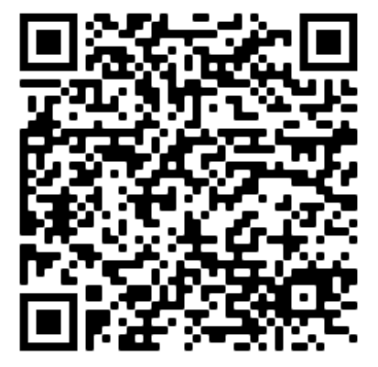

and you can print [**snazzy posters**](https://scottish.sharepoint.com/:b:/s/AHPStudentPlacementPlanningToolkit-Launch08.07.2021/ERu6YYEIZSpHsCgRpNVyj14BTrvixRmi_Nntcj4aIBusEw?e=pV6ajN) if you fancy!

Here’s [**a little snippet**](https://scottish.sharepoint.com/:b:/s/AHPStudentPlacementPlanningToolkit-Launch08.07.2021/Ea7lk-qlAIJFic_xfmfqedUBdfDuuM0JF7m0Cm0Lq6bxyg?e=KmIUCQ)of some of the feedback from the new survey which opened in July 2021- find about things that are going well, things to improve on and some quotes from students about their experiences.

**TRAK RECORDS ACCESS**

I know we keep going on about it but... it is so important to remind students about how to appropriately use TRAK and emphasise that they cannot access their own or family/ friends records.

It is also helpful to remind them that TRAK access is monitored and breaches will be picked up. If you realise that this has happened then please fill in a Datix report.

**SIMULATION BASED EDUCATION**

Simulation based education (SBE) involves re-creating real life situations to give learners a safe environment to practice or rehearse clinical activity, discuss issues, identify strengths and address areas for development. It is a technique which can

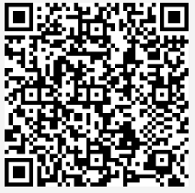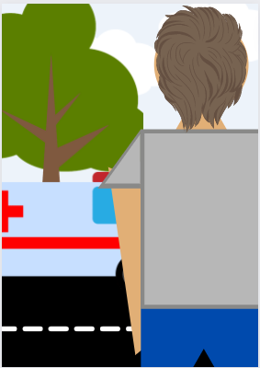

Email, intranet, word of mouth, conferences... There are so many ways of accessing information these days. How do you find out about opportunities and developments in practice education? What is the best way for us to keep in touch with you?

We aim to deliver the information that you need, in the most effective way. So it would help us out if you could answer [**a few questions**](https://forms.office.com/Pages/ResponsePage.aspx?id=veDvEDCgykuAnLXmdF5JmjciTSyHGiBJkT685O3JffFUMDAwU1pBMU01QVVGSlVEOE5NMEtSNFMxMyQlQCN0PWcu)**.**

**COMMUNICATION CHANNELS**

In response to the challenges of the pandemic many people looked to digital tools such as Near Me and Teams in their delivery of student placements. This has proven to be an effective way of using resources and making sure placements could still happen with the restrictions in place.

This shift to the digital realm required development of technical knowledge to be able to use these platforms and they will continue to be part of our clinical work as well as our student placements.

We are keen to support practice educators to continue to use

(or start to use!) these tools and become confident with how to

set them up and use them to meet learning outcomes for

placements. We know there are already great things happening

out there so **if you have a story about using these digital platforms**

**with students that you’d like to share, let us know!**

**Digital Platforms in Practice Education**

The first semester of paramedic placements with AHP Practice Educators finished in December- a big thanks to all those who supported these![**The feedback**](https://scottish.sharepoint.com/:b:/s/AHPStudentPlacementPlanningToolkit-Launch08.07.2021/Ef36zO5O61hLnv08xsGMrcIBNofE78ncEzOYE-Khxfsp_Q?e=CgDDTJ)was very positive from students and educators.

Students have reported gaining knowledge on other AHPs roles, pathways, and patients’ journeys, while educators have commended paramedic students’ positive attitude and keenness to learn and help.

We are looking forward to more placements in the future and would love to support your team taking a paramedic student. If you’re interested get in touch!

**PARAMEDIC UPDATE AND FEEDBACK**



We all work in rewarding but sometimes demanding roles, especially so in the last two years. In recognition of this, NHS Scotland has set up a [**Wellbeing initiative**](https://learn.nes.nhs.scot/37897/national-trauma-training-programme/wellbeing) and in April we will launch a series of Lunch & Learn sessions focusing on this topic.

**So we want to hear from you!** Do you have a story that you wish to share at a Lunch & Learn? Drop us a line and contact Iain: **iain.christie@nhslothian.scot.nhs.uk.**

**WELLBEING**

**TEAM UPDATES**



**Goodbye to Frank**

We would like to say a big thank you to **Frank Martinez** for all his hard work on our practice education team during his secondment. We are sad to say goodbye but wish him all the best with his future plans!

**CONTACT US**

Get in touch at the below email addresses with queries or ideas about practice education. We’re happy to arrange a chat on MS Teams about plans, ideas or concerns about facilitating placements.

**Claire** [claire.matheson2@nhslothian.scot.nhs.uk](mailto:claire.matheson2@nhslothian.scot.nhs.uk)

**Iain** [iain.christie@nhslothian.scot.nhs.uk](mailto:iain.christie@nhslothian.scot.nhs.uk)

**Inbox** [AHPPracticeEducation@nhslothian.scot.nhs.uk](mailto:AHPPracticeEducation@nhslothian.scot.nhs.uk)

