**Footwear Guidance**

In-patients should be encouraged to bring in or have brought in suitable footwear as soon as possible. Suitable footwear is important for maintaining independent mobility and preventing falls.

Advise your patients’ about these tips on shoes and falls prevention:

* soles should be flexible (allows “feeling” the floor)
* high heels and leather soles should be avoided
* laces, buckles or Velcro straps hold the feet firmly in place, preventing them from slipping and open backed slippers should be avoided
* garments such as trousers / skirts / dressing gowns should not trail on the ground

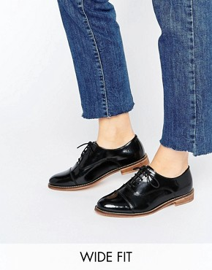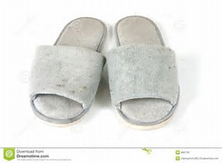

**☺**

**☹**

**Guidance for assessing in-patient footwear for suitability**

* Does the footwear fit?
* Can the person fasten their footwear?
* Can the fastenings be used to secure the shoe or slipper onto the foot
* If they have slippers, have the ‘uppers’ been cut away – if so then this reduces the support provided
* Is the heel in good condition e.g. not worn down or flattened
* Is the upper or sole dirty and can it be cleaned easily
* Does the sole grip
* Is the insole worn down
* Is the sole worn down
* If the person has dressings on their feet, does this prevent them from wearing shoes or slippers
* Does oedema prevent them from wearing shoes / slippers

**Non-slip Socks**

Walking with bare feet can be hazardous and poses a risk of slipping. You can provide non-slips socks however it is always advisable to wear shoes or supportive slippers if possible.

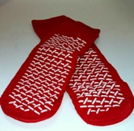If using non-slip socks the correct size should be used and socks must be removed regularly to check the skin to ensure that there are no red or broken areas.