Falls Risk Assessment

# How to complete:

When completing a falls risk assessment it is important to have as much information about the person as possible.

You are making a clinical judgement on whether they are at HIGH risk of falling based on the information you have gathered.

For example:

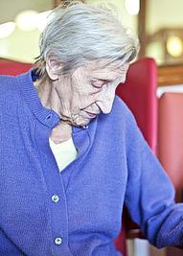

***Mrs Green (78yrs) is admitted with a chest infection and lethargy. She fell in the bathroom and was unable to get up again. She has PMH of anaemia, osteoarthritis, IHD and stroke. She normally mobilises with a walking frame in the house and is generally housebound. She has been confused since admission to ED and family are anxious about her falling again.***

**Falls Risk Assessment:**

Complete and document the screen for more vulnerable patients (5Qs) ***(If answers ‘yes’ to any of the five questions below, the patient is identified as ‘more vulnerable’***.

1. *Has the patient fallen in the last 6 months – including during this admission?*
2. *Does the patient have a 4AT greater than 0 or acute confusion (delirium)?*
3. *Does the patient attempt to walk alone although unsteady or unsafe?*
4. *Does the patient or their relative/s have fear or anxiety regarding falling?*
5. *Based on your clinical judgement, is this patient at high risk of falling?*

**From the information available you will have answered YES to Q1 and possibly to Q2 following 4AT and Q4. The patient has a significant PMH which would indicate possible deficit to limbs and is housebound so mobility will likely be impaired (risk factor for falls). PMH would also indicate that patient takes more than 4 medications (risk factor for falls). Family are anxious about her falling again.**

**This patient would be identified at high risk of falls – even if bedbound – and a full care plan should be completed.**