How to Transfer learnPro Account
Logon to your learnPro account http://nhs.learnprouk.com.
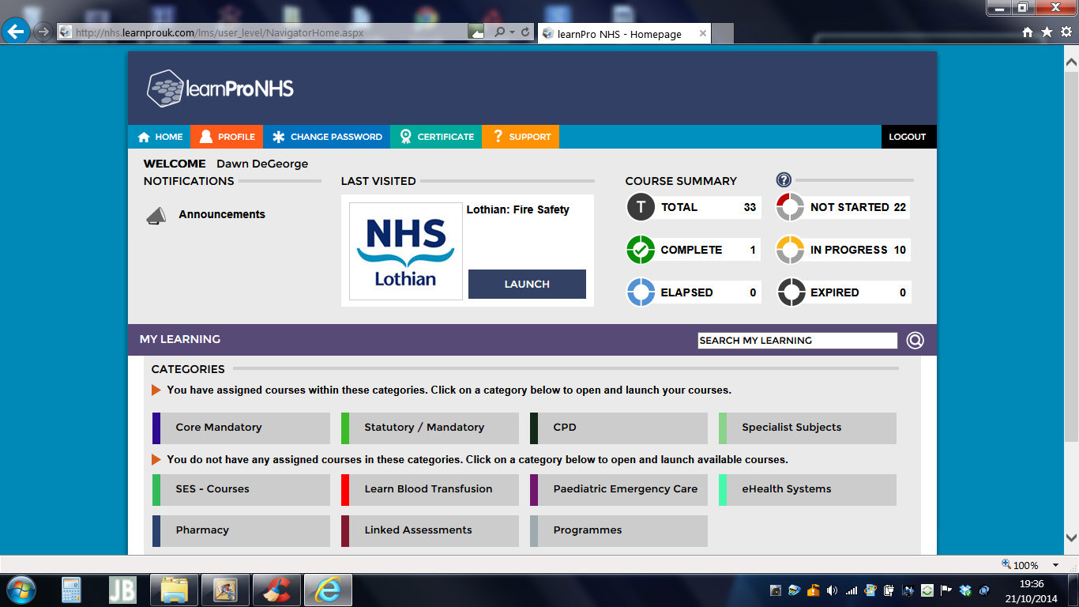 |  |  | Click on Profile tab on the learnPro tool bar
Location and Role

- Location: click on Change
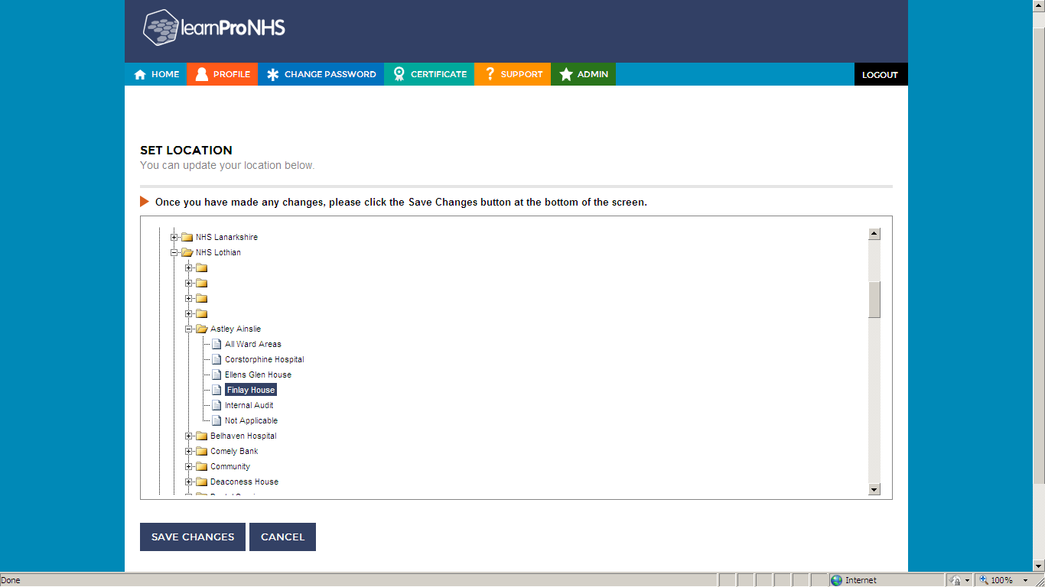 |  |  |  | Set Location  - Click on NHS Lothian  - Click on Hospital / Base  - Click on Ward / Department  - Click on Save Changes
Location and Role

- Role: click on Change
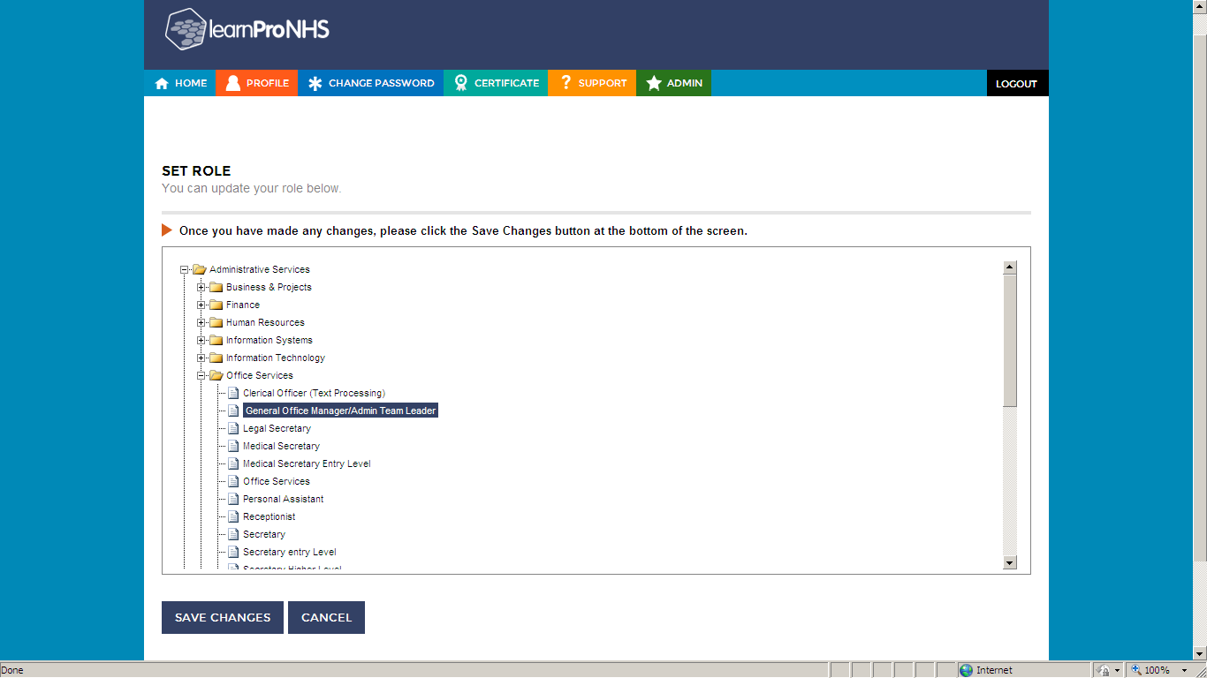 | Set Role  - Click on your job role  - Click on Save Changes
Identification

- learnPro ID Number – click on change
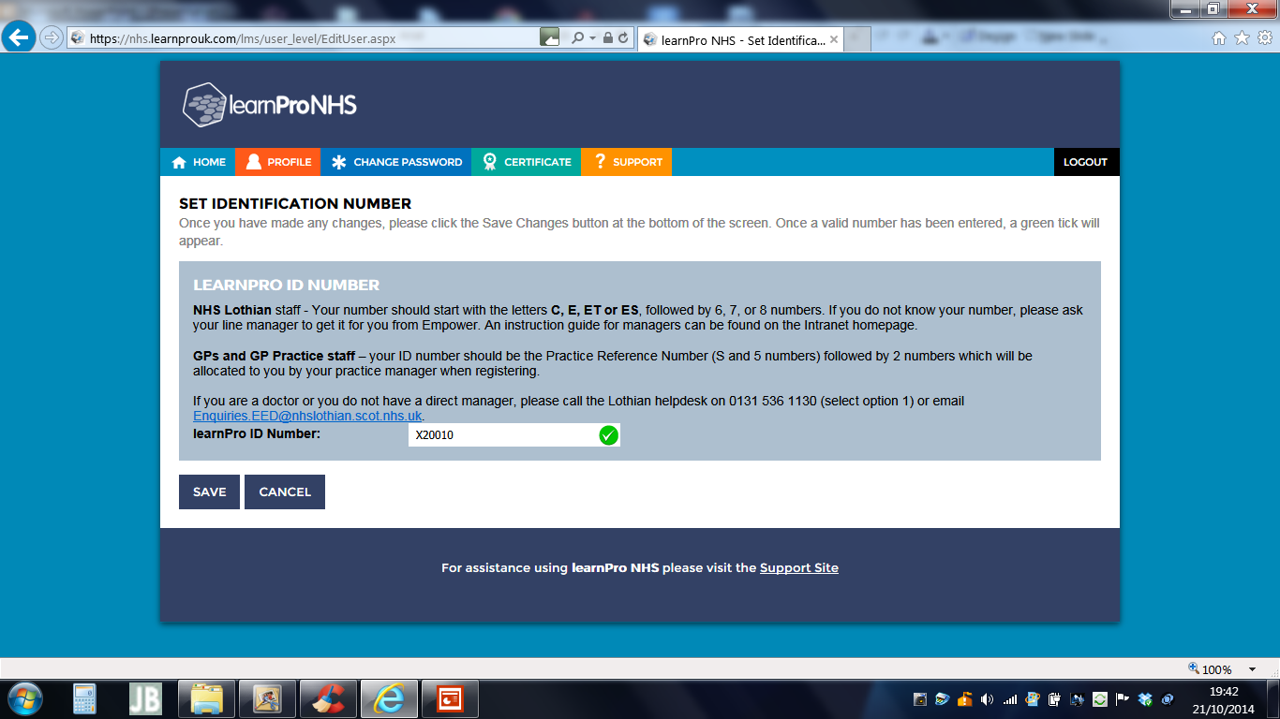 |  | Set Identification Number  - Add your NHS Lothian learnPro ID number in the box  - Click on Save

DTC/21Oct14

T:\Learnpro\_Corporate Induction\Transfer Accounts_21Oct14

