Reflection Template (Driscoll’s)

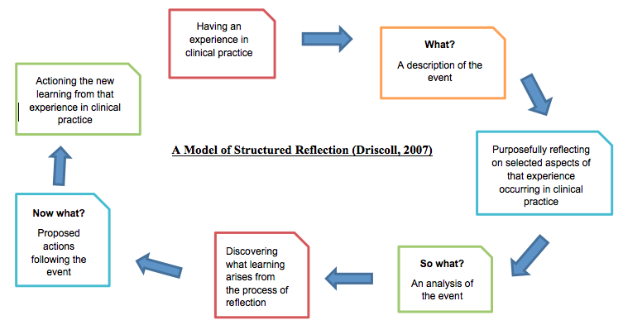

Name:
Date:

What….
What was your experience? | What was I trying to achieve?
What was good / not so good about the experience?

So what ….
So what could/should I have done to make it better? | So what did I base my actions on?
So what did I learn from this experience?

Now what ….
Now what will I do with this learning?

