Gibbs’ Model of reflection (1994)

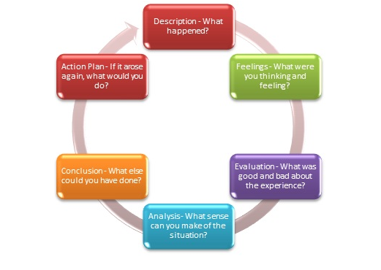

Name:
Date:
Focus on what happened | Step 1: Description  State what happened.
Focus on what happened | Step 2: Feelings  How did that make you feel?
Focus on what happened | Step 3: Evaluation  What went well/ not so well?
Focus on what to do better next time | Step 4: Analysis  What might you have done differently?
Focus on what to do better next time | Step 5: Conclusion  What will you do differently next time?
Focus on what to do better next time | Step 6: Action Plan  What practical steps will you take to improve for next time?

