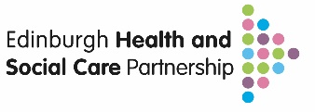
Hannah Cairns & Karina O’Rourke
Hannah.cairns@nhs.scot karina.orourke2@nhs.scot
Abstract
This document outlines the Edinburgh HSCP approach to reducing avoidable harm through falls prevention and management and provides all the tools and resources that you need to get started.

FALLS PREVENTION AND MANAGEMENT FRAMEWORK & TOOLKIT
Pathways and Procedure

Contents

Introduction | Page 2
Why Stratify Falls Risk Levels | Page 3
Falls Prevention and Management Care Bundles | Page 4
Commissioned Falls Prevention Class Descriptors | Page 5
Who Should Use the Screening Tool | Page 6
The Falls Knowledge and Skills Tiers | Page 7
Knowledge and Skills – Tier 1: Informed | Page 8
Knowledge and Skills – Tier 2: Skilled | Page 9
How to Assess for Clinical Frailty Score | Page 10
How to Complete Strength and Balance Test | Page 11
Knowledge and Skills – Tier 3: Expert | Page 12
Level 3 Clinical Pathway | Page 13
Level 3 Clinical Pathway Resource and Referral Routes | Page 14
Digital Self-Assessment and Self-Management Tool | Page 15
Pathway Measurement Plan | Page 16
Pathway Implementation Requirements | Page 17
Toolkit and Resources | Page 18

Introduction
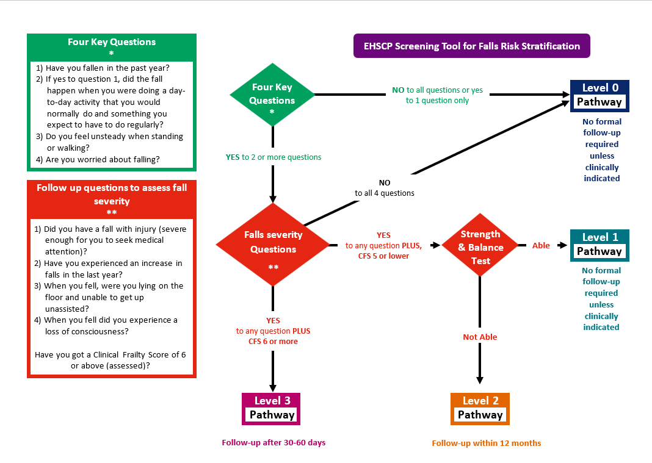
The EHSCP Community Falls Prevention and Management Pathways have been developed for use by a wide range of health and care professionals across the system. They are designed to support the early identification and management of individuals at risk of harm from falls. Using a consistent and structured approach to categorising risk enables equitable access to effective, person-centred support and care.

In Edinburgh, we recognise that many services play a role in the prevention and management of falls. However, to date, our approach has often been inconsistent and reactive, rather than proactive and preventative.

The implementation of the EHSCP Falls Screening Tool will help ensure that:

- Individuals are identified as early as possible using four key questions*.
- Those identified are assessed using a consistent approach to determine the severity of risk through structured follow-up questions**.
- Individuals at greatest risk of harm, who require a comprehensive multifactorial falls assessment (MFA), are referred to an appropriately skilled practitioner.
- Those at risk receive timely support to prevent further deterioration and reduce their risk of harm by accessing the Falls Pathway Care Bundles, which include targeted resources and interventions.

The Falls Risk Screening Tool has been developed in alignment with the World Falls Guidelines (WFG) and the NICE (National Institute for Health and Care Excellence) guidelines Falls: assessment and prevention in older people and in people 50 and over at higher risk

Why Stratify Falls Risk Levels
Risk stratification in falls prevention can identify individuals at varying levels of risk, allowing for targeted, proportionate interventions. This ensures timely, person-centred support, maximises resource use, and helps reduce avoidable harm by matching the right level of care to each person’s needs.
The Falls Risk Screening Tool is used to identify an individual's risk of harm from one or more falls. Based on the level of risk identified, the appropriate Falls Care Bundle can be offered. These bundles are person-centred, preventative, and focused on early intervention.
Preventing falls and intervening early involves taking proactive steps to reduce risk and address underlying factors as soon as possible. This includes managing medical conditions, reviewing medications, encouraging physical activity and good nutrition, improving home safety, and ensuring timely access to support.
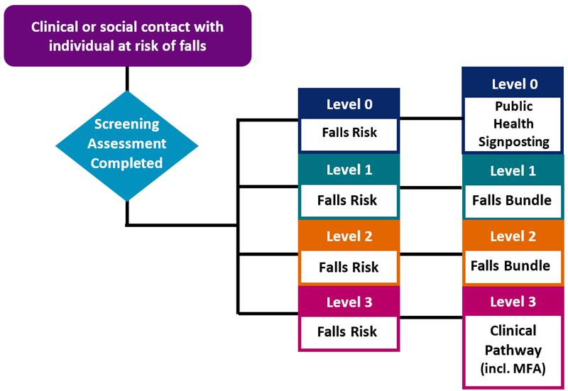
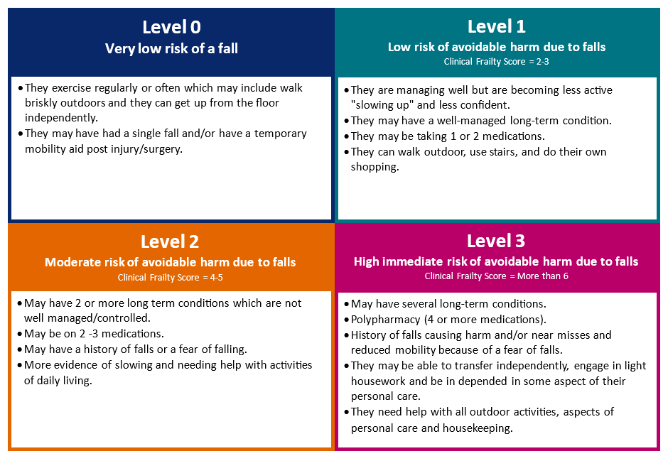
In Edinburgh, we have developed Falls Care Bundles that are directly linked to the risk levels identified by the Screening Tool. These bundles offer a structured, evidence-based approach to improving care and outcomes. They consist of practical, proven interventions and resources that, when used together, help enhance safety and reduce avoidable harm.

Falls Prevention and Management Care Bundles

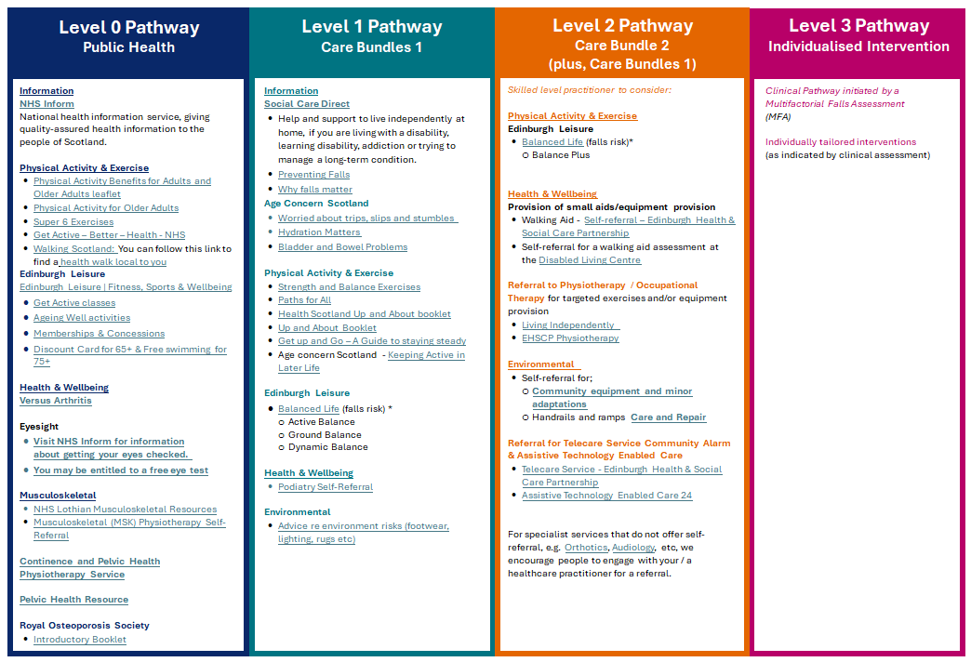

The Falls Prevention and Management Care bundles are kept under continuous review to ensure that they are maintained and updated in accordance with the availability of resources. For the most up to date versions please see Community Falls Prevention and Management Pathways Falls Care Bundles webpages.

Commissioned Falls Prevention Class Descriptors

LEVEL 2 PATHWAY
Balance Plus
This foundation class is designed to improve strength and mobility as well as build balance confidence. Delivered three times a week for 12 weeks this class uses a range of gentle, progressive exercises that help build strength, balance and mobility.
The class is suitable for people who have a clinical frailty score of 5 or less and can stand for up to 40minutes of the 60minute class. There will be mixture of standing and seated exercises and participants will always have the support of a chair for balance if required.
This class is not suitable for people with a clinical frailty score of 6 or more or for permanent wheelchair users.
LEVEL 1 PATHWAY
Active Balance
This studio-based class uses functional exercises that promote daily movement patterns which focus on building strength, mobility and co-ordination. Delivered once a week for 12 weeks this class is suitable for people who have a clinical frailty score of 5 or less and can complete a strength and balance test.
Participants should be able to stand for up to 40minutes of the 60minute class, but there will be a chair available for stability if required. Participants will be given their own exercise band and booklet to keep, and they will be encouraged to do some exercises at home between the weekly classes to help them get the most out of the programme.
This class is not suitable for people with a clinical frailty score of 6 or more or for permanent wheelchair users.

Dynamic Balance
This class uses a circuit training format, where participants move through a series of stations, each focusing on different aspects of functional fitness that are essential for everyday movements. Delivered once a week for 12 weeks this class is suitable for those who can move around unsupported between stations for up to 45 minutes and is aimed at those who are mobile and have greater existing strength and balance.
This class is not suitable for wheelchair users, those that rely on mobility aids or for people with a clinical frailty score of 6 or more.

Grounded balance
This class teaches people how to safely get up and down from the floor. Participants will practise moving between standing, sitting, kneeling and lying positions. Delivered once a week for 12 weeks this class builds flexibility, strength, and confidence. This class is suitable for people who have the strength and mobility to move between the floor and a chair independently.
This class is not suitable for wheelchair users, those that rely on mobility aids or for people with a clinical frailty score of 6 or more.

Who should use the Screening Tool

The screening tool has been designed to support everyone working across the health and social care system to identify those at risk of falls at the earliest point. The EHSCP Falls Prevention Knowledge and Skills Framework provides an outline of the knowledge, skills, and learning required by individuals and teams to deliver the pathway consistently. It is structured across three cumulative levels, with each level building on the learning from the previous one. As learners progress, they are encouraged to continue using earlier resources to deepen their understanding.

The diagram below illustrates how the Knowledge and Skills Tiers align with the Screening Tool.

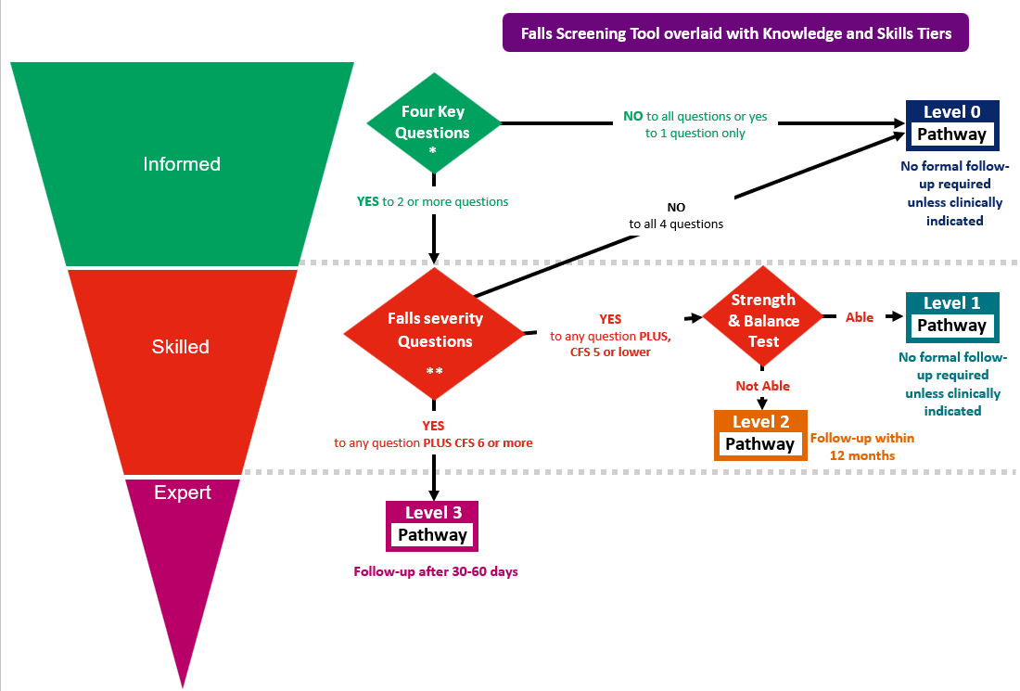

The Falls Knowledge and Skills Tiers

The diagram below illustrates how individuals and teams align with each skill tier, based on their job-related knowledge and competencies. It is intended as a guide only, as actual implementation will depend on agreement within specific teams and their existing skills and expertise.

In implementing the Falls Prevention and Management Pathway, it’s important to recognise that the agreed roles for individuals and teams do not always directly reflect their capabilities. Often, the focus is on the time needed to complete the screening, distracting away from the core activity of the service.

The following sections provide a detailed explanation of each Knowledge and Skills Tier and the associated knowledge and ability.
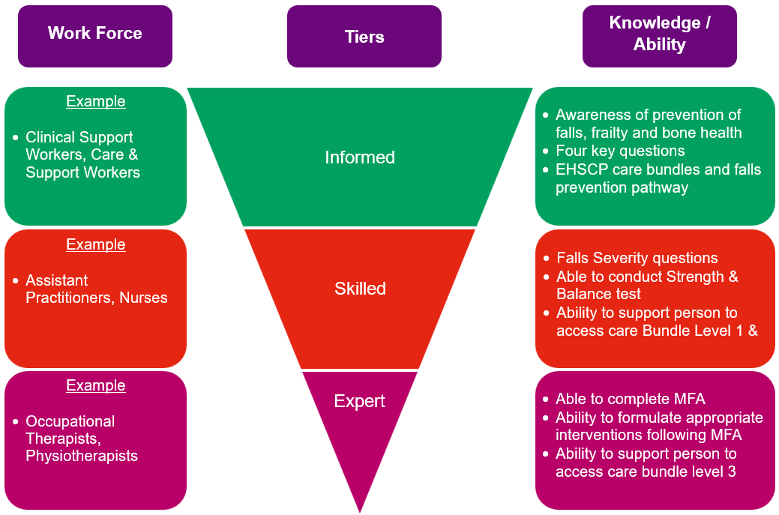

Knowledge and Skills – Tier: Informed
Foundation knowledge and skills for all wellbeing, Health and Social Care practitioners who work with adults who may be at risk of falls
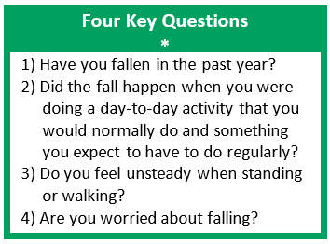
Falls are largely avoidable—and preventing them is everyone’s business. It is vital that all wellbeing, health and social care staff who work directly with people, families, or carers understand why falls, frailty, and bone health matter, and how they can contribute to falls prevention and management.
Staff should be able to recognise when to initiate the Falls Risk Screening Tool by asking the Four Key Questions*. Based on the responses:
- If the person is assessed as being at very low risk (Level 0), they should be provided with reliable public health information and signposted to resources that support a healthy, active lifestyle. This is information is contained in Care Bundle 0.
- If the person answers ‘yes’ to two or more of the Four Key Questions, the Falls Severity Question should be used to determine whether further assessment is needed (see the next section on Tier 2 – Skilled).

It’s important to use every opportunity to engage with individuals, supporting self-management and ensuring access to the appropriate level of care to help prevent falls wherever possible.
Knowledge
Why falls, frailty and bone health matter and what strategies can help support prevention and management of falls.

Four key questions and how to respond to answers given.

Falls prevention Care Bundles and how to access them.
Skills
Recognise when to ask the four key questions.

Provide relevant information and signposting for people on Level 0 pathway.

Be able to connect person to appropriate services to access Care Bundles 1-3.
Learning Resources
TURAS e-Learning Module
- Falls, Frailty and Bone Health: Prevention and management
- Falls prevention is everyone’s business – Video

My Learning Hub (CEC)
- Falls in older people

EHSCP information
- Overview of Falls pathway and Four key questions.
- Level 0 Care Bundles

Knowledge and Skills – Tier: Skilled
Knowledge and skills required for practitioners who have regular and significant involvement with people who fall or are at risk of falling

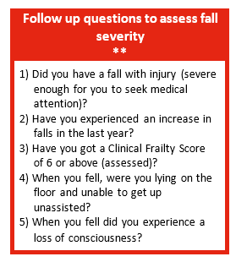
Knowledge and Skills – Tier: Skilled
Foundation knowledge and skills for all wellbeing, Health and Social Care Practitioners who work with adults who may be at risk of falls

Skilled practitioners at Tier 2 should understand when and how to ask the Follow-up Questions to Assess Falls Severity, which includes the use of the Clinical Frailty Scale (CFS), also known as the Rockwood Frailty Scale. They must also know how to respond appropriately based on the results.

The combination of severity questions and the CFS helps determine the individual’s level of risk:
- If the person answers ‘no’ to all questions, they are considered very low risk and should be signposted to trusted public health information to help maintain a healthy, active lifestyle – Level 0 Care Bundle.
- If the person answers ‘yes’ to one or more questions and has a CFS of 5 or lower, they are at low to moderate risk and should be offered a Strength and Balance Test.
- If the person answers ‘yes’ to one or more questions and has a CFS of 6 or higher, they are at high and immediate risk and should be referred for a Multifactorial Falls Assessment (MFA).
Knowledge
Falls severity questions and how to respond to answers given.

Knowledge of basic functional anatomy.

Understanding of strength and balance and importance in preventing falls.

Falls prevention Care Bundles and how to access them.
Recognise when to ask the falls severity questions.

Ability to conduct and interpret strength and balance test.

Provide relevant information and signposting for people on Level 1 or 2 pathway.

Be able to make a referral for a MFA.
e-Learning
Clinical Frailty score e-Learning - Clinical Frailty Scale (CFS) Training Module - Overview | Rise 360

Competency
Strength and balance test – how to conduct and what to do with the results.

Severity questions and what action to take based on answers

Knowledgeable on Level 1 & 2 Care Bundle resources
Strength & Balance Exercises - NHS inform
Super 6 leaflet
Preventing Falls - NHS inform
Why falls matter - NHS inform
Learning Resources
Skills

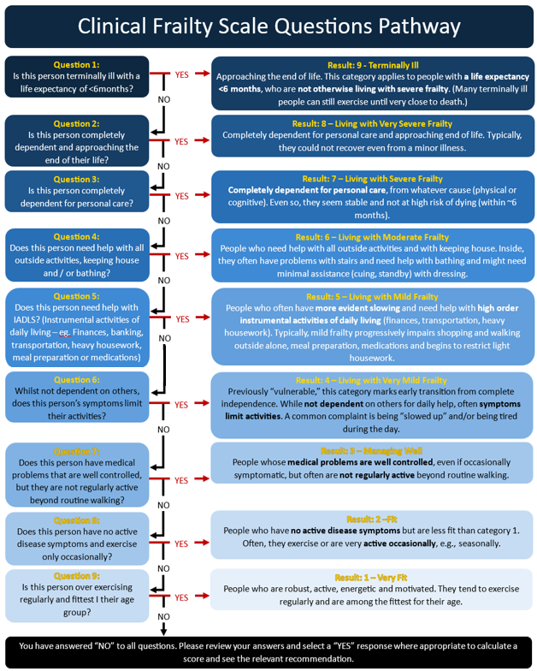
How to Assess for Clinical Frailty Score
The Clinical Frailty Scale (CFS) is incorporated into falls screening to help differentiate between those who are mildly frail (CFS 5) and those with more advanced frailty (CFS 6 and above). This distinction is important, as individuals at CFS 5 are often slowing and require some support with higher-level activities but remain able to engage meaningfully in active rehabilitation and falls prevention interventions. By contrast, those at CFS 6 and above typically require more regular assistance with daily activities, and their falls management may need to focus on tailored, supportive approaches that balance rehabilitation potential with safety, comfort, and quality of life.
Tier 2 practitioners are required to assess an individual's Clinical Frailty Score (CFS) to support accurate identification of their falls risk level. An NHS-accredited CFS app is available via the App Store on Apple devices, which may be useful; however, it is not currently available on Android devices. As an alternative, the question-based algorithm below can be used to determine an individual’s CFS.

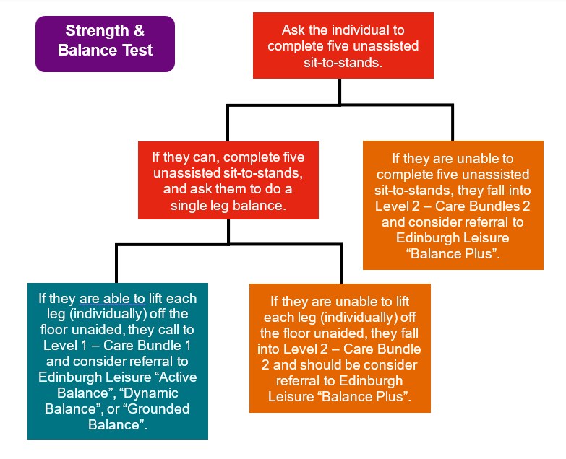
How to Complete Strength and Balance Assessment
If a person answers ‘yes’ to one or more of the Follow-up Questions to Assess Falls Severity and has a Clinical Frailty Score (CFS) of 5 or lower, they are at low to moderate risk and should undergo a Strength and Balance functional ability test.

A Tier 2 Skilled Practitioner should be able to both carry out and interpret these functional tests, which are widely used in health and care settings to assess physical performance—specifically strength, balance, and mobility. These assessments help gauge an individual’s capacity to carry out daily activities and are especially relevant for older adults and those with long-term conditions.

The tests include:
- Sit-to-Stand (STS) Test: Assesses lower limb strength and overall functional ability. The person is asked to stand up from a seated position and sit back down five times without using their hands.
- Single Leg Balance (SLB) Test: Measures static postural control. The person is asked to stand on one leg for as long as possible, with the other leg lifted off the ground.

Interpreting the Results:
The outcome of the Strength and Balance assessment will determine the individual's level of risk:
- Level 2 / Moderate Risk:
  - If they cannot complete 5 Sit-to-Stands, or
  - If they can complete 5 Sit-to-Stands but cannot complete the Single Leg Balance,
Then they should be directed to Falls Care Bundles 0, 1, and 2, and a referral should be considered for Edinburgh Leisure’s Balanced Plus physical activity programme.
- Level 1 / Low Risk:
  - If they can complete both the Sit-to-Stand and Single Leg Balance tests,
Then they should be directed to Falls Care Bundles 0 and 1, and consideration should be given to referral to Edinburgh Leisure’s Active Balance, Dynamic Balance, or Grounded Balance programmes.

Knowledge and Skills – Tier: Expert
Knowledge and skills required for practitioners who are competent to complete multifactorial falls assessments with people who have been identified as level 3 falls risks and are at high risk of falling
Medication review: Identifying and adjusting medications that may contribute to falls, such as those causing dizziness or drowsiness.
Vision assessment and correction: Addressing visual impairments that may affect gait and balance.
Home hazard assessment and modification: Identifying and removing potential hazards in the home environment, such as loose rugs or poor lighting.
Footwear assessment and recommendations: Ensuring proper footwear with good grip and support.
Cognitive and psychological support: Addressing cognitive impairments or psychological factors that may increase fall risk.

Examples of interventions resulting from MFA:

A Tier 3 practitioner has an enhanced skill set and is qualified to carry out a Multifactorial Falls Assessment (MFA) for individuals identified as being at Level 3 / High Immediate Risk of harm from a fall.

An MFA is a comprehensive assessment that looks beyond simple risk prediction. It is used to identify and address the wide range of factors that may contribute to a person's risk of falling. This assessment is delivered as part of the Level 3 Clinical Pathway and is tailored to the individual’s specific needs.

The MFA explores a range of factors contributing to fall risk, including medical conditions, medications, mobility and balance, vision, cognitive function, environmental hazards (such as home safety), and footwear or foot health.

Multifactorial Falls Assessment.

Evidence based interventions for falls prevention.

Goal Setting.

Rehabilitation process and approaches.
Ability to complete multifactorial falls assessment.

Ability to interpret assessment and formulate appropriate intervention plan.

Dynamic risk assessment.

Provide relevant information, signposting and interventions for people on Level 3 Pathway.
Knowledge
Skills
Learning Resources
4AT Delirium screening tool | Right Decisions

Dizziness: A practical, evidence based intro to Vestibular Assessment, Treatment & Rehab

Multi –factorial Falls Assessment (MFA)

Local and National Guidelines – Falls Support and Education

Level 3 Clinical Pathway

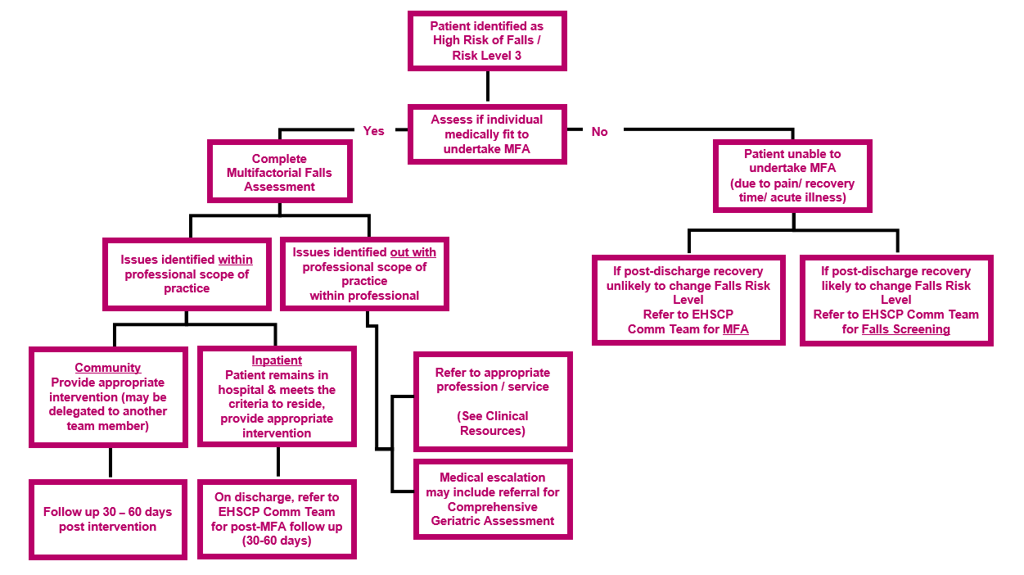
The process below offers Tier 3 Expert Clinicians clear guidance to support them in carrying out the Risk Level 3 clinical pathway, minimise duplicated efforts, and improve patient outcomes.

Level 3 Clinical Pathway Resources & Referral Routes
The Falls Prevention and Management Care Bundles and referral routes are kept under review to ensure that they are maintained and updated in accordance with the availability of resources. For the most up to date versions please see Community Falls Prevention and Management Pathways Falls Care Bundles webpages.
Click on NHS Lothian link for the complete Care Pathway for Level 3 (High Immediate Risk of Harm).
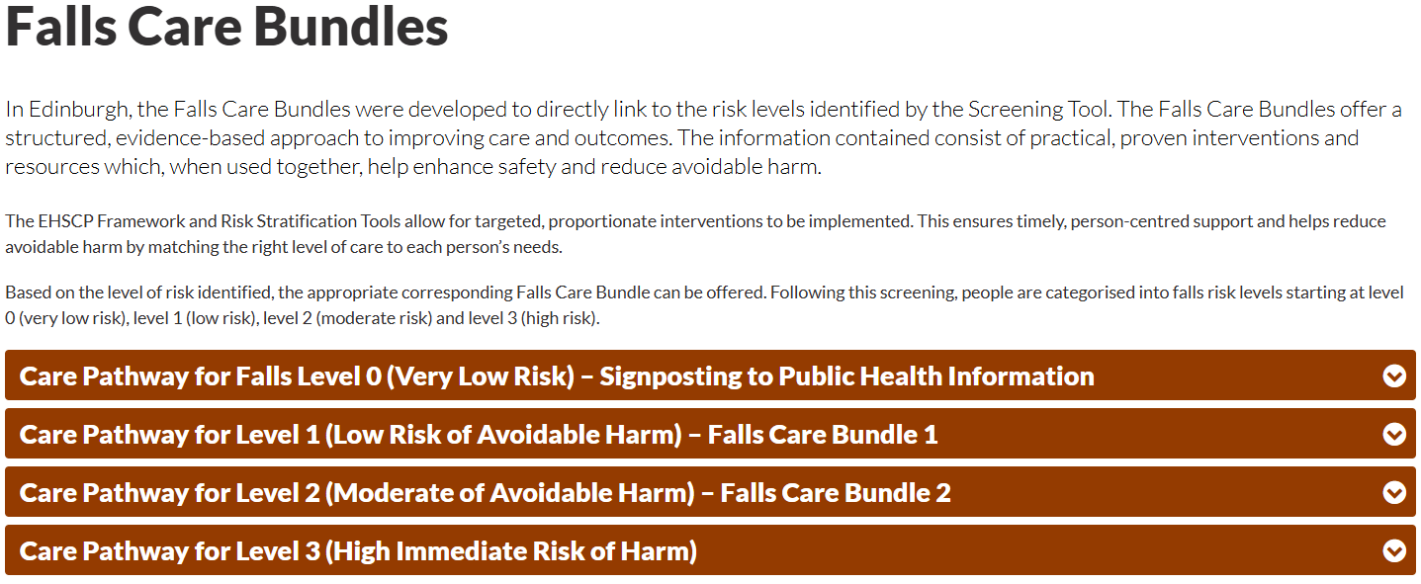

Digital Self-Assessment and Self-Management Tool [Under Development]
The supported self-assessment and self-management resource is a key part of how the EHSCP delivers falls prevention and management. It helps people stay involved in their own care, giving them easy access to personalised advice, tools, and resources—while still being supported by professionals when needed.
It’s especially useful for those who don’t regularly see health or care services, making it easier to spot early signs of risk, like reduced balance or confidence. By encouraging people to stick with proven activities—such as strength and balance exercises or checking their home for hazards—it helps stop falls before they happen.
The digital tool also helps everyone stay on the same page. With shared access to resources, individuals, carers, and professionals can work together more effectively. This not only supports better care but also helps take pressure off busy frontline services, letting them focus more on people with complex needs.
The supported self-management tool can be accessed here.
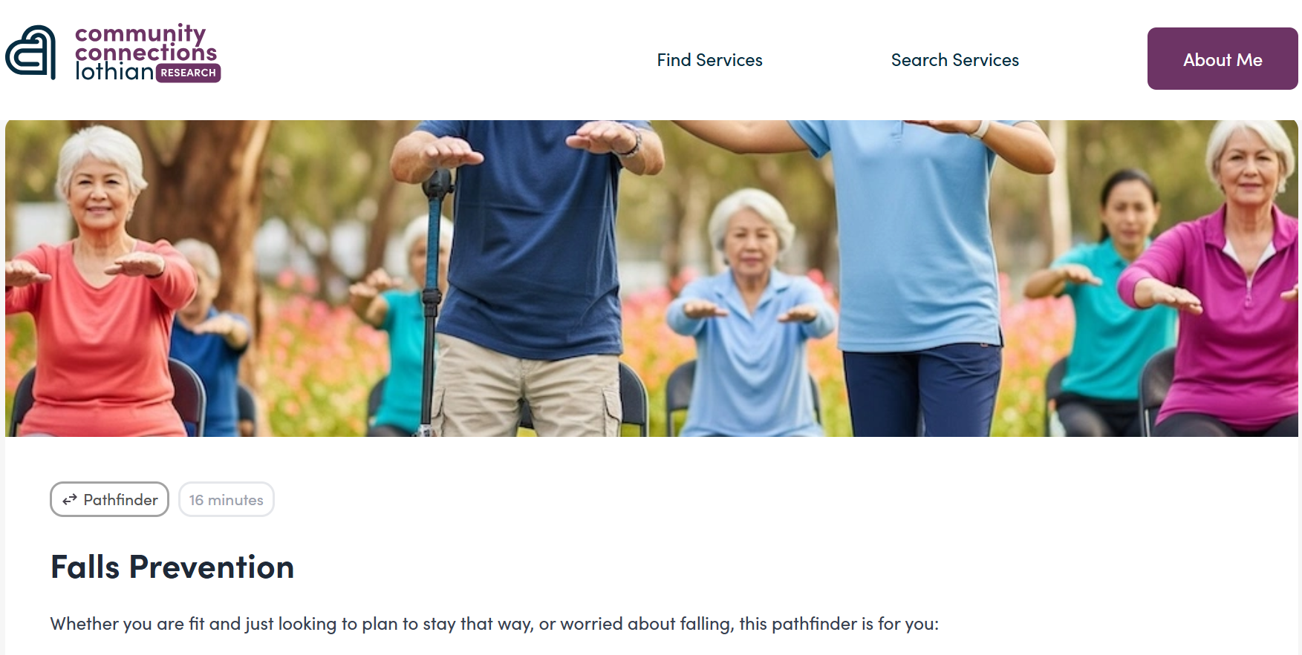


Pathway Measurement Plan
A measurement plan has been developed to monitor progress and determine whether the implemented changes are improving outcomes for people at risk of falls. The framework is expected to evolve over time, allowing for ongoing refinement.
 | Measure | Definition | Source | Desirable Outcome
Outcome Measures (Measurement of Success) | - Number of people attending the emergency department due to falls  - Number of emergency admissions due to #NoF  - Number of frequent fallers, frequency of falls | The original aim of the Falls Prevention and Management Pathway is to reduce avoidable harm caused by falls in the population of Edinburgh (over 50 years) reducing the need for unscheduled care (A&E attendance and hospital admission) | - Lothian Falls Dashboard | - Reduction 25% by December 2025  - Reduction 25% by December 2025  - Increase in time between falls
Process Measures | - Number of people identified through falls screening – levels 1-2  - Number of people provided with level 1-2 care bundles  - Number of people identified at falls risk level 3  - Number of people having Multifactorial Falls Assessment (MFA)  - Number of people on level 3 pathway and actions taken  - Demand in OT and PT Community Team (for MFA’s)  - People undertaking the level 1 and level 2 Edinburgh Leisure prevention programmes and outcomes | The process measures surround the application of the screening tool, care bundles and Multifactorial Assessments (MFAs) | - Service reports  - Data from digital self-management tool  - Edinburgh Leisure reports | 4. Increase over time  5. Increase over time  6. Increase over time  7. Increase over time  8. Increase over time  9. Increase over time  10. Improved outcomes
Balancing Measures | - Patient experience of risk level pathways  - Staff experience | The balancing measures ensure that any unintended impacts are monitored and measured. | - Patient engagement  - Staff engagement | 11. Experience of receiving care  12. Experience of providing care

Pathway Implementation Requirements
Community Pathway | Operational Requirements | Self-Management Pathway  Requires digital access to  self-management tool
Person at risk identified through wellbeing, clinical or social care interaction | Knowledge and Skills Tier 1 individual / team | Person at risk identified through online supported self-management platform
Knowledge & Skills Tier: Informed  Asks 4 key questions | Knowledge and Skills Tier 1 individual / team  Risk level 0 - Access to Care Bundle 0  Risk level 1+  Only, if necessary (due to competency or time limitations), refer to Tier 2 team / service | Answers 4 key questions  [if Risk Level 0 – directed to access level 0 Care Bundle]
Knowledge & Skills Tier: Skilled  Asks 4 falls severity questions  Assess CFS Score | Knowledge and Skills Tier 2 individual / team | Answers fall severity questions  [if Risk Level 0 – directed to access level 0 Care Bundle]  Answers CFS questions to obtain CFS Score
Knowledge & Skills Tier: Skilled  Carries out strength and balance test | Knowledge and Skills Tier 2 individual / team  Risk level 1 - Access to Care Bundle 1 & refer to Edinburgh Leisure  Risk level 2 - Access to Care Bundle 2 & refer to Edinburgh Leisure  Only, if necessary (due to competency/time limitations), refer to Knowledge and Skills Tier 3 team / service | Completes strength and balance test  [if risk level 1 – directed to access level 1 Care Bundle]  [if risk level 2 – directed to access level 2 Care Bundle]  Self-referral to Edinburgh Leisure – levels 1 & 2
Knowledge & Skills Tier: Expert  Completes MFA and undertakes clinical pathway | Knowledge and Skills Tier 3 individual / team  Access to risk level 3 clinical pathway | Self-referral to Community OT/PT for MFA

Toolkit and Resources
There are a range of tools and resources that have been developed to support and enable individuals and teams to implement the Falls Prevention & Management Pathways – these can be accessed below.

Resource | Guides
Community Falls Prevention & Management Pathways –  Website for HSCP Workforce | Framework and Toolkit – Community Falls Prevention and Management Pathways
Community Falls Prevention & Management Pathways  Presentation Slides | EHSCP Falls Framework Introduction
The Clinical Frailty Scale (CFS) | The Clinical Frailty Scale (CFS)
Multifactorial Falls Assessment  Guideline for Use | EHSCP Multifactorial Falls Assessment Guidance
Multifactorial Falls  Assessment Form | EHSCP Multifactorial Falls Assessment
EHSCP Community Falls Prevention Informed Level  Training Pack | EHSCP Community Falls Prevention Informed Level training pack
EHSCP Community Falls Prevention Skilled Level  Training Pack | EHSCP Community Falls Prevention Skilled Level training pack
EHSCP Community Falls Prevention Expert Level  Training Pack | EHSCP Community Falls Prevention Expert Level training pack
Falls Screening Tool  Standard Operating Procedure | Falls Screening SOP
Falls Screening Tool  Recording Form | SOP - Falls Prevention Screening Tool

