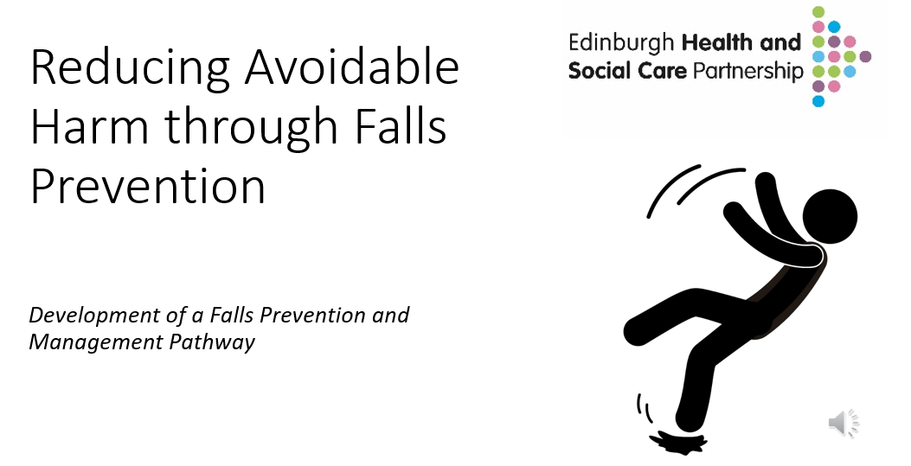

Informed Level Training Pack

Click on icon for full presentation.

Knowledge and Skills – Tier: Informed
Foundation knowledge and skills for all wellbeing, Health and Social Care practitioners who work with adults who may be at risk of falls
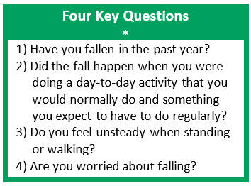
Falls are largely avoidable—and preventing them is everyone’s business. It is vital that all wellbeing, health and social care staff who work directly with people, families, or carers understand why falls, frailty, and bone health matter, and how they can contribute to falls prevention and management.
Staff should be able to recognise when to initiate the Falls Risk Screening Tool by asking the Four Key Questions*. Based on the responses:
- If the person is assessed as being at very low risk (Level 0), they should be provided with reliable public health information and signposted to resources that support a healthy, active lifestyle. This is information is contained in Care Bundle 0.
- If the person answers ‘yes’ to two or more of the Four Key Questions, the Falls Severity Question should be used to determine whether further assessment is needed (see the next section on Tier 2 – Skilled).

It’s important to use every opportunity to engage with individuals, supporting self-management and ensuring access to the appropriate level of care to help prevent falls wherever possible.

Knowledge
Why falls, frailty and bone health matter and what strategies can help support prevention and management of falls.

Four key questions and how to respond to answers given.

Falls prevention Care Bundles and how to access them.
Skills
Recognise when to ask the four key questions.

Provide relevant information and signposting for people on Level 0 pathway.

Be able to connect person to appropriate services to access Care Bundles 1-3.
Learning Resources
TURAS e-Learning Module
- Falls, Frailty and Bone Health: Prevention and management
- Falls prevention is everyone’s business – Video

My Learning Hub (CEC)
- Falls in older people

EHSCP information
- Overview of Falls pathway and Four key questions.
- Level 0 Care Bundles
Additional NHS Lothian Falls Education and Training and available
Falls Education and Training – Falls Support and Education

Knowledge and Skills – Tier: Skilled
Knowledge and skills required for practitioners who have regular and significant involvement with people who fall or are at risk of falling

Level 0
Very low risk of a fall

- They exercise regularly or often which may include walk briskly outdoors and they can get up from the floor independently.
- They may have had a single fall and/or have a temporary mobility aid post injury/surgery.
Knowledge & Skills Framework
Level
3

Level
1 / 2

Level
0

Informed (Level 0)

- General awareness of factors impacting falls
- General awareness of public health information

Level 0 Pathway
Public Health
Skilled level practitioner to consider:
- Information
- Physical Activity and Exercise
- Health and Wellbeing

For the most updated list, please click link to visit the Falls Care Bundles web page:
Falls Care Bundles – Community Falls Prevention and Management Pathways

