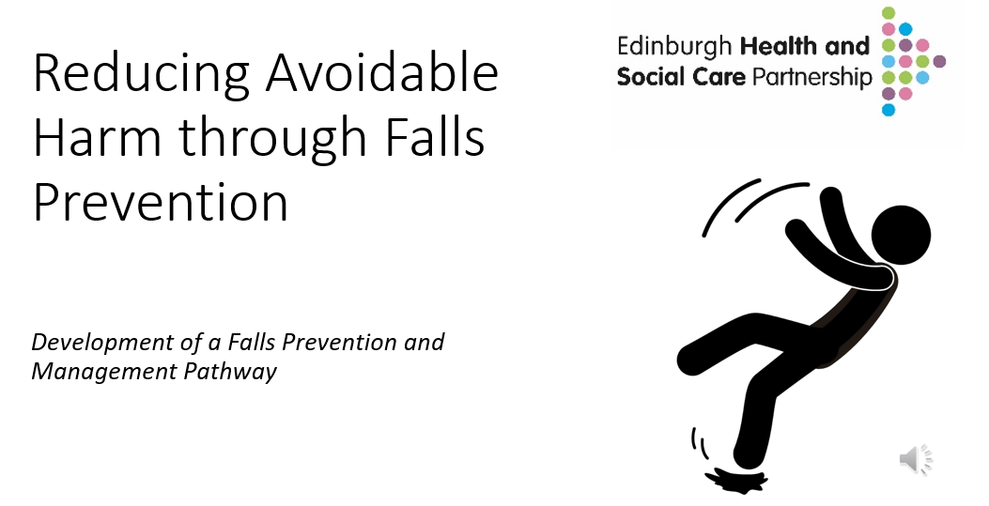
Expert Level Training Pack

Click on icon for full presentation.

Knowledge and Skills – Tier: Expert
Knowledge and skills required for practitioners who are competent to complete multifactorial falls assessments with people who have been identified as level 3 falls risks and are at high risk of falling.
Medication review: Identifying and adjusting medications that may contribute to falls, such as those causing dizziness or drowsiness.
Vision assessment and correction: Addressing visual impairments that may affect gait and balance.
Home hazard assessment and modification: Identifying and removing potential hazards in the home environment, such as loose rugs or poor lighting.
Footwear assessment and recommendations: Ensuring proper footwear with good grip and support.
Cognitive and psychological support: Addressing cognitive impairments or psychological factors that may increase fall risk.

Examples of interventions resulting from MFA:

A Tier 3 practitioner has an enhanced skill set and is qualified to carry out a Multifactorial Falls Assessment (MFA) for individuals identified as being at Level 3 / High Immediate Risk of harm from a fall.

An MFA is a comprehensive assessment that looks beyond simple risk prediction. It is used to identify and address the wide range of factors that may contribute to a person's risk of falling. This assessment is delivered as part of the Level 3 Clinical Pathway and is tailored to the individual’s specific needs.

The MFA explores a range of factors contributing to fall risk, including medical conditions, medications, mobility and balance, vision, cognitive function, environmental hazards (such as home safety), and footwear or foot health.

Multifactorial Falls Assessment.

Evidence based interventions for falls prevention.

Goal Setting.

Rehabilitation process and approaches.
Ability to complete multifactorial falls assessment.

Ability to interpret assessment and formulate appropriate intervention plan.

Dynamic risk assessment.

Provide relevant information, signposting and interventions for people on Level 3 Pathway.
Knowledge
Skills
Learning Resources
Additional NHS Lothian Falls Education and Training and available
Falls Education and Training – Falls Support and Education
Pan Lothian Training Resources – Falls Support and Education

4AT Delirium screening tool | Right Decisions

Dizziness: A practical, evidence based intro to Vestibular Assessment, Treatment & Rehab

Multi –factorial Falls Assessment (MFA)

Local and National Guidelines – Falls Support and Education

Falls Risk Level 3 – Clinical Pathway
Patient identified as
High Risk of Falls /
Risk Level 3

No
Yes
Patient unable to undertake MFA
(due to pain/ recovery time/ acute illness)

Assess if individual medically fit to undertake MFA
If post-discharge recovery likely to change Falls Risk Level
Refer to EHSCP Comm Team for Falls Screening

If post-discharge recovery unlikely to change Falls Risk Level
Refer to EHSCP
Comm Team for MFA

Complete Multifactorial Falls Assessment

Issues identified out with professional scope of practice
within professional scope of practice

Issues identified within professional scope of practice
Issues identified within professional scope of practice

Refer to appropriate profession / service
(See Clinical Resources)
Inpatient
Patient remains in hospital & meets the criteria to reside, provide appropriate intervention
Community
Provide appropriate intervention (may be delegated to another team member)

Medical escalation
may include referral for Comprehensive Geriatric Assessment
Follow up 30 – 60 days post intervention
On discharge, refer to EHSCP Comm Team for post-MFA follow up (30-60 days)

Level 3
High immediate risk of avoidable harm due to falls
Clinical Frailty Score = More than 6
- May have several long-term conditions.
- Polypharmacy (4 or more medications).
- History of falls causing harm and/or near misses and reduced mobility because of a fear of falls.
- They may be able to transfer independently, engage in light housework and be in depended in some aspect of their personal care.
- They need help with all outdoor activities, aspects of personal care and housekeeping.
- More evidence of slowing and needing help with activities of daily living.

Knowledge & Skills Framework
Level
3

Level
1 / 2

Level
0

- Autonomous clinical decision maker.
- Registered Occupational Therapist or Physiotherapist.
- Referrer to a wide range of other health care professions.
Expert (Level 3)

Level 3 Pathway
Individualised Intervention (plus Care Bundles 1&2)

Referral to Community Occupational Therapy and/or Physiotherapy Services for Multifactorial Falls Assessment (MFA)

For the most updated list, please click link to visit the Falls Care Bundles web page:
Falls Care Bundles – Community Falls Prevention and Management Pathways

