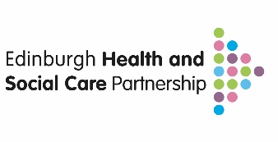

Standard Operating Procedure

Falls Prevention and Management Screening Tool

Approved by: | Date Approved:
Authors: Hannah Cairns & Karina O’Rourke | Effective from: 22 September 2025
Version: V 0.2 | Review Date: 22 September 2026

Index

Section |  | Page
1. | Purpose | 2.
2. | Introduction | 2.
3. | Scope | 3.
4. | Definitions | 3.
5. | Specific Procedure | 5.
6. | Appendices | 7.
7. | Change History | 7.

- purpose

The EHSCP Community Falls Prevention & Management Pathway has been developed for use by a wide range of health and care professionals across the system. It is designed to support the early identification and management of individuals at risk of harm from falls. Using a consistent and structured approach to categorising risk enables equitable access to effective, person-centred support and care.

- introduction
The EHSCP Falls Screening Tool will help ensure that:

- Individuals are identified as early as possible using four key questions*.
- Those identified are assessed using a consistent approach to determine the severity of risk through structured follow-up questions**.
- Individuals at greatest risk of harm, who require a comprehensive multifactorial falls assessment (MFA), are referred to an appropriately skilled practitioner.
- Those at risk receive timely support to prevent further deterioration and reduce their risk of harm by accessing the Falls Pathway Care Bundles, which include targeted resources and interventions.

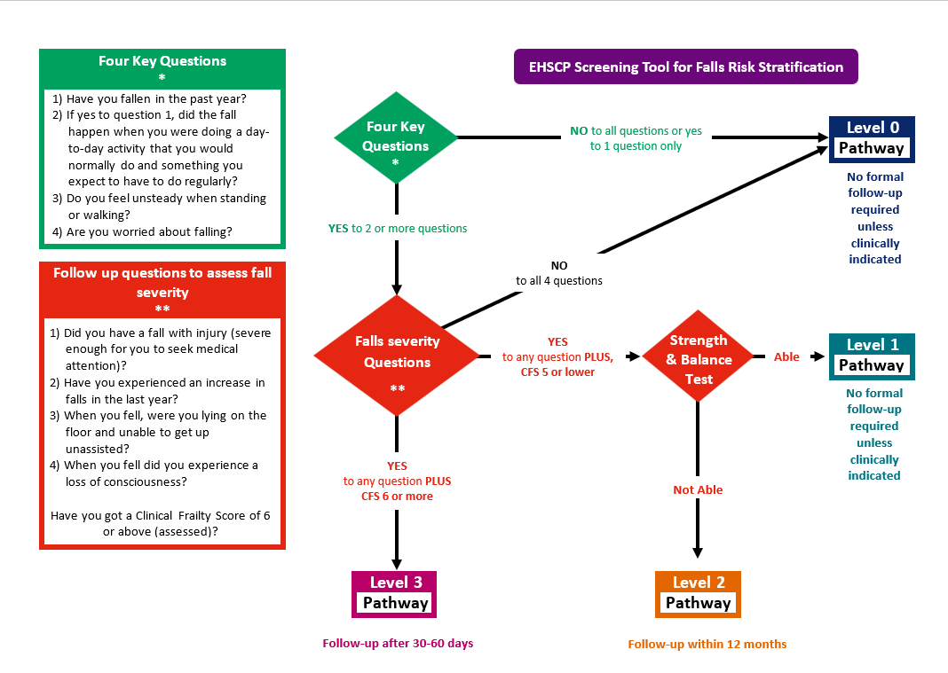
- Scope
The screening tool has been designed to support everyone working across the health and social care system to identify those at risk of falls at the earliest point.

The EHSCP Falls Prevention Knowledge & Skills Framework provides an outline of the knowledge, skills, and learning required by teams and individuals to deliver the pathway consistently. It is structured across three cumulative levels, with each level building on the learning from the previous one.

The diagram below illustrates how the Knowledge and Skills Tiers align with the Screening Tool.

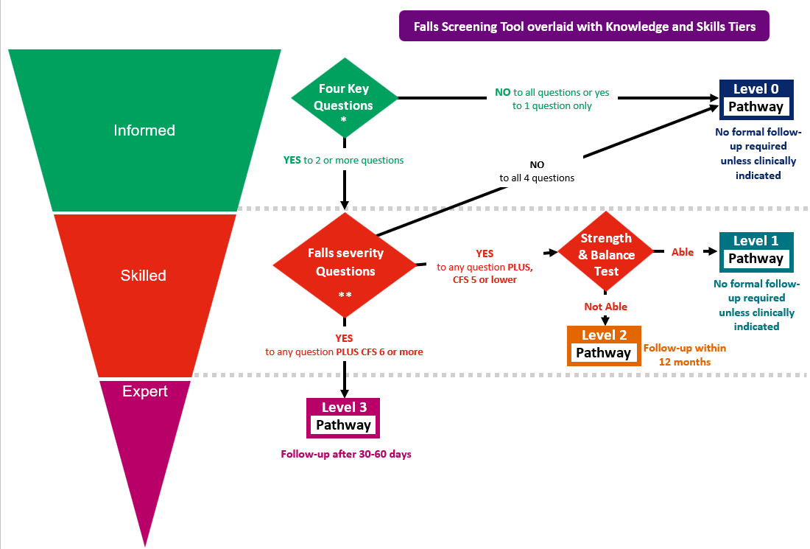

- Definitions
Clinical Frailty Score (CFS) –is a 9-point scale developed to quickly assess an individual’s overall level of frailty, based on their physical function, comorbidities, cognition, and degree of independence. It is incorporated into falls screening to help differentiate between those who are mildly frail (CFS 5) and those with more advanced frailty (CFS 6 and above).
Falls Care Bundles – a group of evidence-based interventions that, when performed together, lead to a better outcome for a patient. These align directly to the individuals identified risk level,
  - Level 0 (Public health signposting),
  - Level 1 (Targeted falls prevention bundle),
  - Level 2 (Higher intensity falls prevention bundle),
  - Level 3 (Clinical pathway including full MFA).

Falls Knowledge and Skills Tiers
All wellbeing, Health and Social Care practitioners who work with adults who may be at risk of falls (see appendix for training packs)
  - Informed - Staff should be able to recognise when to initiate the Falls Risk Screening Tool by asking the Four Key Questions*
  - Skilled – Staff should understand when ask the Follow-up Questions to Assess Falls Severity, which includes the use of the CFS
  - Expert – Stahh require enhanced skill set and are qualified to carry out a Multifactorial Falls Assessment (MFA) for individuals identified as being at Level 3 / High Immediate Risk of harm from a fall.

Falls Risk Levels – An individual’s identified level of risk having been screened using the screening tool
  - Level 0 (Very low risk),
  - Level 1 (Low risk),
  - Level 2 (Moderate risk),
  - Level 3 (High risk)
Four Key Questions Falls Severity Questions
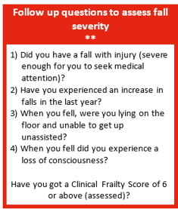
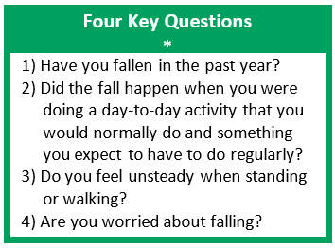

Strength and Balance Test - is included in falls screening to identify physical deficits that increase fall risk, enabling targeted interventions such as exercise or physiotherapy to improve stability and independence. The tests include a sit-to-stand test and a single leg balance test (see section 5 for details).
Multifactorial Falls Assessment (MFA) - is a structured review of medical, physical, functional, environmental, and psychosocial factors to identify risks and create a personalised plan to reduce falls and support independence (see appendix for MFA template and guidance).

- SPECIFIC PROCEDURE
  - Read and ensure you are familiar with the EHSCP Falls Prevention and Management Framework and Toolkit (see appendix) and ensure that you have completed the appropriate competency, at a minimum the informed tier, of the knowledge and skills training resources prior to using the screening tool.

  - When you meet someone, you deem at risk of falls or who your service role requires you to screen for falls, first ask the four key questions.

  - If the person answers ‘yes’ to only one question or ‘no’ to all questions they are deemed to be very low risk (Level 0), they should be provided with and signposted level 0 care bundle.

  - If the person answers ‘yes’ to two or more questions, the Falls Severity Question should be asked.

  - If you are trained to skilled tier, progress to ask the falls severity questions.

  - If you are trained to informed tier, or it has been agreed for your service to do so, refer to a local service that can complete the falls screening tool.

  - If the person answers ‘no’ to all questions, they are considered very low risk and should be signposted to Level 0 Care Bundle.

  - If the person answers ‘yes’ to one or more questions, assess the clinical frailty score (CFS) using the question-based algorithm below

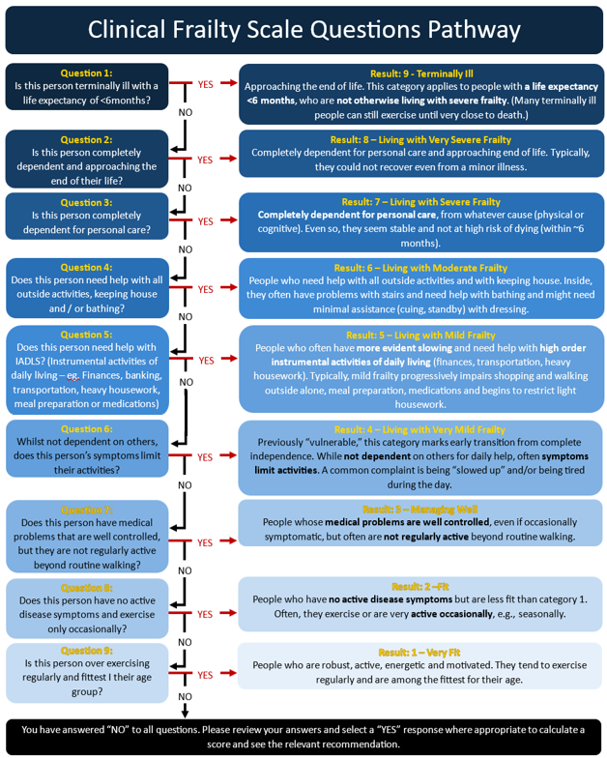

  - If the person has a CFS of 5 or lower, they are at low to moderate risk and should undergo a Strength and Balance test. Use the decision tree (below) to complete this test and define the risk level appropriately.

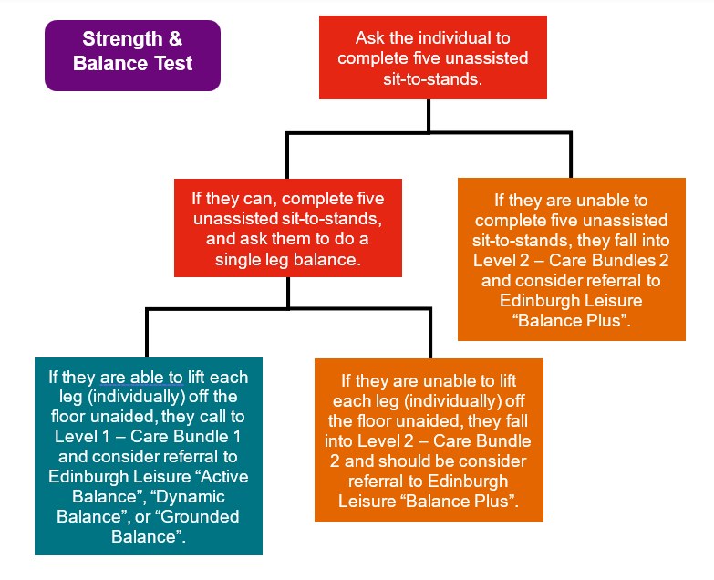

  - If the person has a CFS of 6 or higher, they are at high and immediate risk, and you should follow the level 3 Clinical Pathway.

  - If you or a member of your team are trained to expert tier, continue with the level 3 clinical pathway which should be initiated with a Multifactorial Falls Assessment (MFA).

  - If you or a member of your team are not trained to expert tier, refer to the Hub Therapy Team for level 3 clinical pathway which should be initiated with a Multifactorial Falls Assessment (MFA).

  - Ensure follow up arrangements have been put in place according to falls risk level
    - Level 3 – follow up after 30-60 days
    - Level 2 – follow up within 12 months
    - Level 0/1 – no formal follow up required unless clinical indicated

- Appendices
Resource | Guides
Community Falls Prevention & Management Pathways –  Website for EHSCP Teams / Staff | Community Falls Prevention and Management Pathways – NHS Lothian | Staff
Community Falls Prevention & Management Pathways  Presentation Slides | EHSCP Falls Framework Introduction
The Clinical Frailty Scale (CFS) | The Clinical Frailty Scale (CFS)
Multifactorial Falls Assessment  Guideline for Use | EHSCP Multifactorial Falls Assessment Guidance
Multifactorial Falls  Assessment Form | EHSCP Multifactorial Falls Assessment
EHSCP Community Falls Prevention Informed Level Training Pack | EHSCP Community Falls Prevention Informed Level training pack
EHSCP Community Falls Prevention  Skilled Level Training Pack | EHSCP Community Falls Prevention Skilled Level training pack
EHSCP Community Falls Prevention  Expert Level Training Pack | EHSCP Community Falls Prevention Expert Level training pack

- Change History
Revision | Date | Changes | Edited By
Version 0.1 | September 2025 | New SOP | Hannah Cairns
Version 0.2 | 17 September 2025 | Appendices added. | Karina O’Rourke
Version 1.0 | 27 October 2025 | Website link added.  Updated training packs added | Karina

