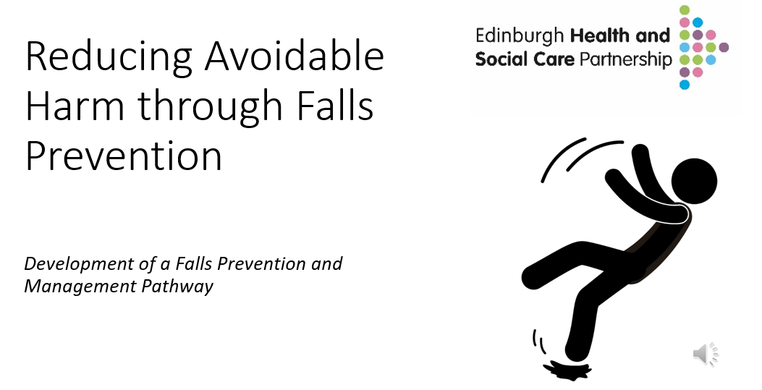

Skilled Level Training Pack

Click on icon for full presentation.

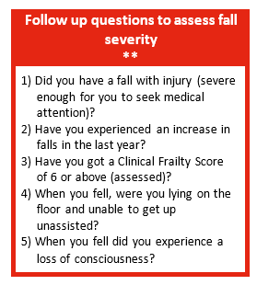
Knowledge and Skills – Tier: Skilled
Foundation knowledge and skills for all wellbeing, Health and Social Care Practitioners who work with adults who may be at risk of falls

Skilled practitioners at Tier 2 should understand when and how to ask the Follow-up Questions to Assess Falls Severity, which includes the use of the Clinical Frailty Scale (CFS), also known as the Rockwood Frailty Scale. They must also know how to respond appropriately based on the results.

The combination of severity questions and the CFS helps determine the individual’s level of risk:
- If the person answers ‘no’ to all questions, they are considered very low risk and should be signposted to trusted public health information to help maintain a healthy, active lifestyle – Level 0 Care Bundle.
- If the person answers ‘yes’ to one or more questions and has a CFS of 5 or lower, they are at low to moderate risk and should be offered a Strength & Balance Test.
- If the person answers ‘yes’ to one or more questions and has a CFS of 6 or higher, they are at high and immediate risk and should be referred for a Multifactorial Falls Assessment (MFA).

e-Learning
Clinical Frailty score e-Learning - Clinical Frailty Scale (CFS) Training Module - Overview | Rise 360

Competency
Strength and balance test – how to conduct and what to do with the results.

Severity questions and what action to take based on answers

Knowledgeable on Level 1 & 2 Care Bundle resources
Strength & Balance Exercises - NHS inform
Super 6 leaflet
Preventing Falls - NHS inform
Why falls matter - NHS inform
Recognise when to ask the falls severity questions.

Ability to conduct and interpret strength and balance test.

Provide relevant information and signposting for people on Level 1 or 2 pathway.

Be able to make a referral for a MFA.
Falls severity questions and how to respond to answers given.

Knowledge of basic functional anatomy.

Understanding of strength and balance and importance in preventing falls.

Falls prevention Care Bundles and how to access them.
Knowledge
Skills
Learning Resources
Additional NHS Lothian Falls Education and Training and available
Falls Education and Training – Falls Support and Education

Level 2
Moderate risk of avoidable harm due to falls
Clinical Frailty Score = 4-5
- May have 2 or more long term conditions which are not well managed/controlled.
- May be on 2 -3 medications.
- May have a history of falls or a fear of falling.
- More evidence of slowing and needing help with activities of daily living.

Knowledge & Skills Framework
Level
3

Level
1 / 2

Level
0

Skilled (Levels 1&2)

- Prescriber of small aides, equipment and technology.
- Referrer to Edinburgh Leisure for Steady Steps Programme.
- Referrer to Community Occupational Therapy and Physiotherapy services.

Level 2 Pathway
Care Bundle 2 (plus, Care Bundles 1)
Skilled level practitioner to consider:
- Physical Activity and Exercise
- Health and Wellbeing
- Environmental

For the most updated list, please click link to visit the Falls Care Bundles web page:
Falls Care Bundles – Community Falls Prevention and Management Pathways

Level 1
Low risk of avoidable harm due to falls
Clinical Frailty Score = 2-3

- They are managing well but are becoming less active "slowing up" and less confident.
- They may have a well-managed long-term condition.
- They may be taking 1 or 2 medications.
- They can walk outdoor, use stairs, and do their own shopping.
Knowledge & Skills Framework
Level
3

Level
1 / 2

Level
0

Skilled (Levels 1&2)

- TURAS Falls module.
- Assessor of Strength and Balance Test.
- Clinical Frailty Score (CFS).

Level 1 Pathway
Care Bundle 1
Skilled level practitioner to consider:
- Information
- Physical Activity and Exercise
- Health and Wellbeing
- Environmental

For the most updated list, please click link to visit the Falls Care Bundles web page:
Falls Care Bundles – Community Falls Prevention and Management Pathways

