Balanced Life
As someone who works with people who have had, or are at risk of having, a fall we would like to update you on Edinburgh Leisure’s new falls prevention pathway, Balanced Life, which features in the new Falls Care Bundles for Edinburgh. Information on the Falls Care Bundles for Edinburgh can be found here https://services.nhslothian.scot/fallssupport/i-live-in-edinburgh/
Balanced Life, which replaced our Steady Steps programme from 30th June 2025, is a 12week physical activity referral programme, offering a range of tailored classes which build strength, balance and mobility, supporting people to maintain their independence and enhance their quality of life through targeted, evidence-based exercises delivered by specially qualified instructors.
The table below provides an overview of each of the classes within our Balanced Life programme which you can refer to.
LEVEL 2 PATHWAY
Balance Plus
This foundation class is designed to improve strength and mobility as well as build balance confidence. Delivered three times a week for 12 weeks this class uses a range of gentle, progressive exercises that help build strength, balance and mobility.
The class is suitable for people who have a clinical frailty score of 5 or less and are able to stand for up to 40minutes of the 60minute class. There will be mixture of standing and seated exercises and participants will always have the support of a chair for balance if required.
This class is not suitable for people with a clinical frailty score of 6 or more or for permanent wheelchair users.

LEVEL 1 PATHWWAY
Active Balance
This studio-based class uses functional exercises that promote daily movement patterns which focus on building strength, mobility and co-ordination. Delivered once a week for 12 weeks this class is suitable for people who have a clinical frailty score of 5 or less and can complete a strength & balance test.
Participants should be able to stand for up to 40minutes of the 60minute class, but there will be a chair available for stability if required. Participants will be given their own exercise band and booklet to keep, and they will be encouraged to do some exercises at home between the weekly classes to help them get the most out of the programme.
This class is not suitable for people with a clinical frailty score of 6 or more or for permanent wheelchair users.

Dynamic Balance
This class uses a circuit training format, where participants move through a series of stations, each focusing on different aspects of functional fitness that are essential for everyday movements. Delivered once a week for 12 weeks this class is suitable for those who can move around unsupported between stations for up to 45 minutes and is aimed at those who are mobile and have greater existing strength and balance.
This class is not suitable for wheelchair users, those that rely on mobility aids or for people with a clinical frailty score of 6 or more.

Grounded balance
This class teaches people how to safely get up and down from the floor. Participants will practise moving between standing, sitting, kneeling and lying positions. Delivered once a week for 12 weeks this class builds flexibility, strength, and confidence. This class is suitable for people who have the strength and mobility to move between the floor and a chair independently.
This class is not suitable for wheelchair users, those that rely on mobility aids or for people with a clinical frailty score of 6 or more.

Please see appendix for the referral process. Once you know what class the individual should attend you can make your referral through our online portal using this link:
https://eur03.safelinks.protection.outlook.com/?url=https%3A%2F%2Fforms.edinburghleisure.co.uk%2Fedinburghleisure%2Fform%2FActiveCommunitiesBalancedLifeReferralForm%2Fformperma%2FuymUbdMpg8rsX5niVwWM0RBw0iFGCw7o6JN13POaJzk&data=05%7C02%7CMariAsher%40edinburghleisure.co.uk%7C400359fb80da4baf668a08dd80a737fc%7Cc23b47f5d2de4d8e9eb6e51e8d53e9af%7C0%7C0%7C638808177876839178%7CUnknown%7CTWFpbGZsb3d8eyJFbXB0eU1hcGkiOnRydWUsIlYiOiIwLjAuMDAwMCIsIlAiOiJXaW4zMiIsIkFOIjoiTWFpbCIsIldUIjoyfQ%3D%3D%7C0%7C%7C%7C&sdata=ba%2FWVOFYaGw8%2BwGEtBMSARyjX%2F1pDG1VKoInP1%2Bpux0%3D&reserved=0

*Please note that we are no longer accepting referrals on a Steady Steps referral form.
If you have questions regarding our new Balanced Life programme, please contact Mari Asher or Becca Rodger using the contact information below:
mariasher@edinburghleisure.co.uk
rebeccarodger@edinburghleisure.co.uk

Appendix
Balanced Life Referral Process
To refer someone to a Balanced Life class you should undertake the following steps:

EHSCP Falls Screening Tool 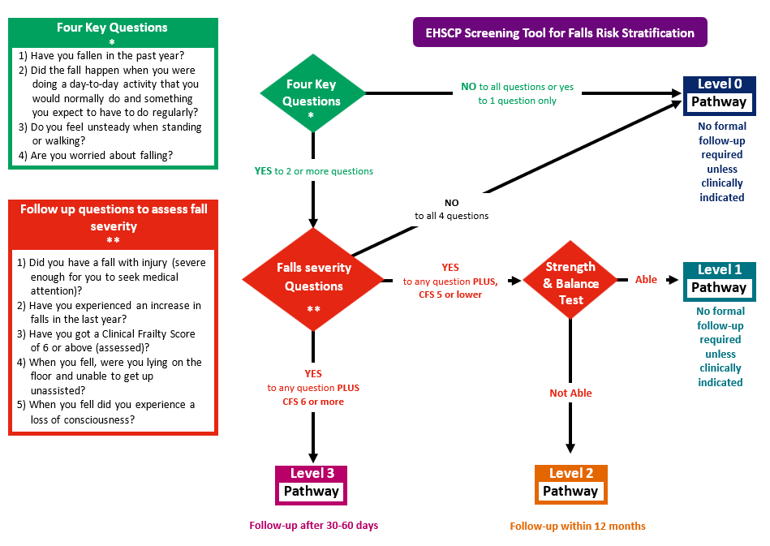
Strength & Balance Assessment
