**How to Create a LearnPro Account**

Click on the following link to open LearnPro NHS

<https://nhs.learnprouk.com/>

Click on **Create** **Account**

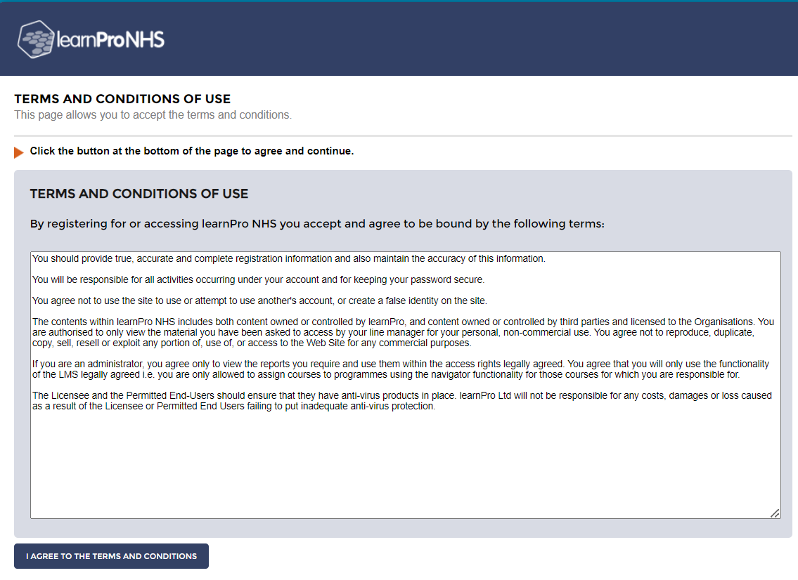

Click on **I AGREE TO THE TERMS AND CONDITIONS** button

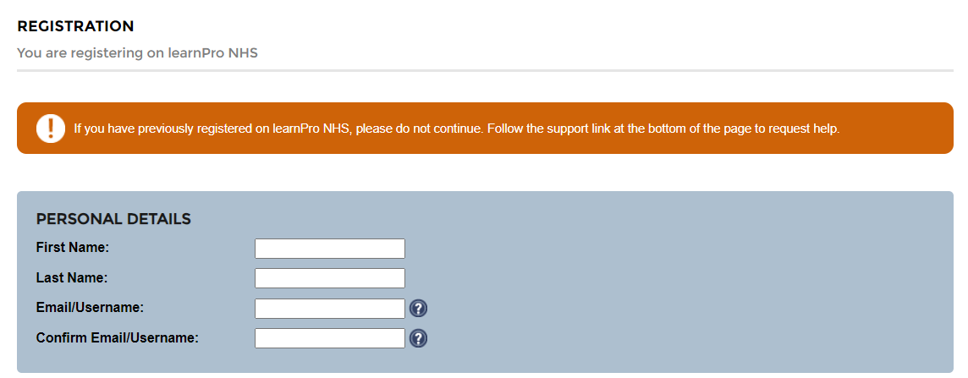

Add your **PERSONAL DETAILS**

Your **Email / Username** should be your NHS email address. If you are still waiting for this to be issued, you can use a personal email and update later.

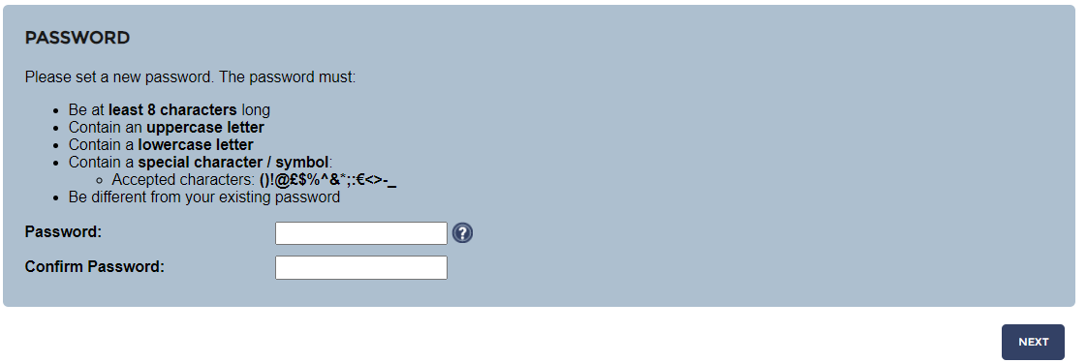

Create a **PASSWORD**

Follow password guidance.

Click on **NEXT** button

Add your **LOCATION** and **JOB ROLE**

Click on the **LOCATION** tab



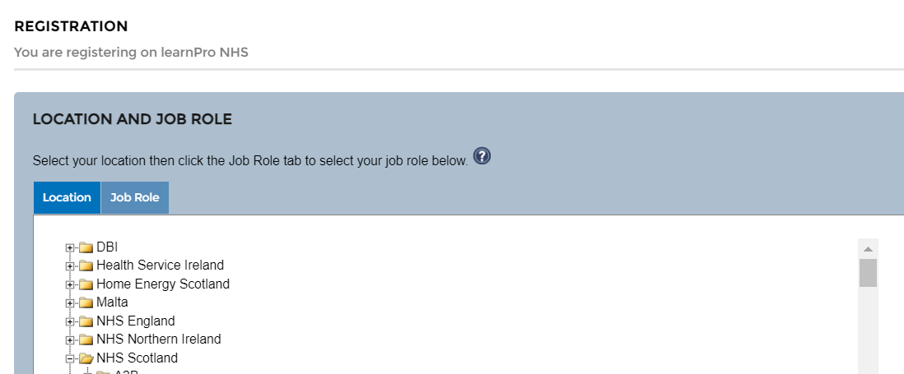

Click on **NHS Scotland**

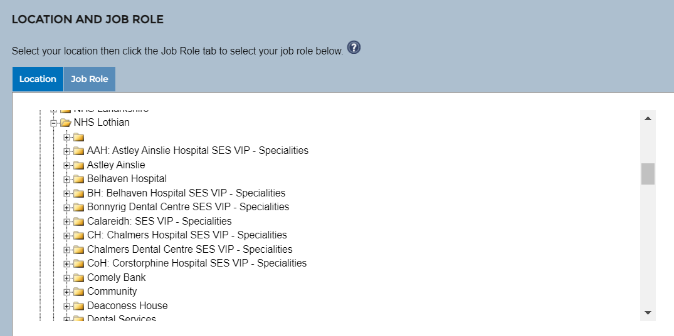

Use the scroll bar on the right-hand side to scroll down the page to find **NHS Lothian**.

Click on **NHS Lothian**

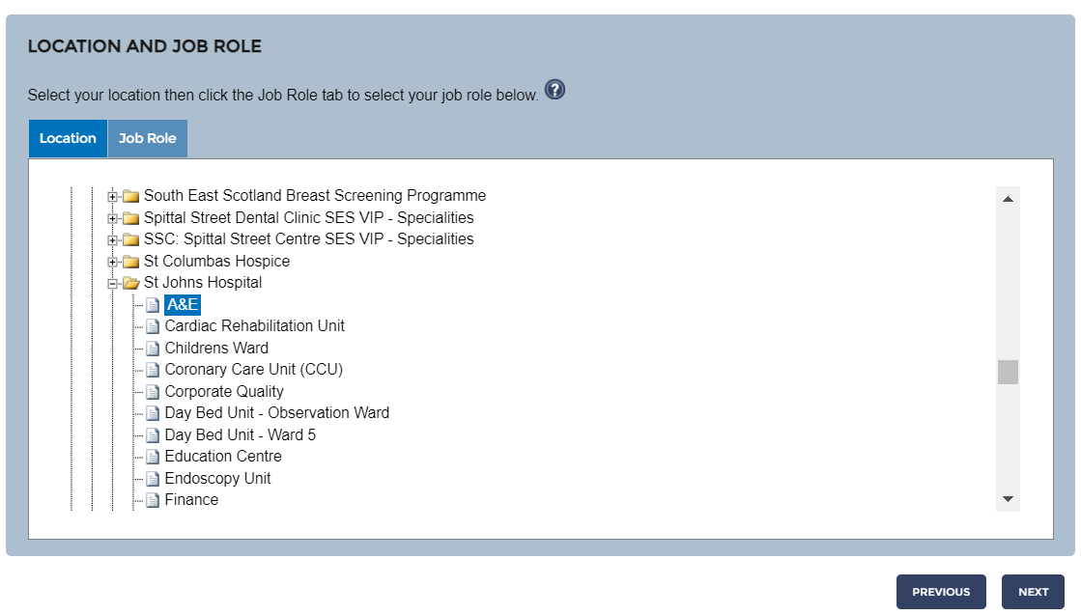

Scroll down the page to find your location and ward

For example:

Click on **St Johns Hospital** Click on **A&E**

You have successfully selected your location when the text is highlighted in blue.

If you are unable to find your ward / department, please select **Other**

Click on the **NEXT** button.

Click on the **JOB ROLE** tab



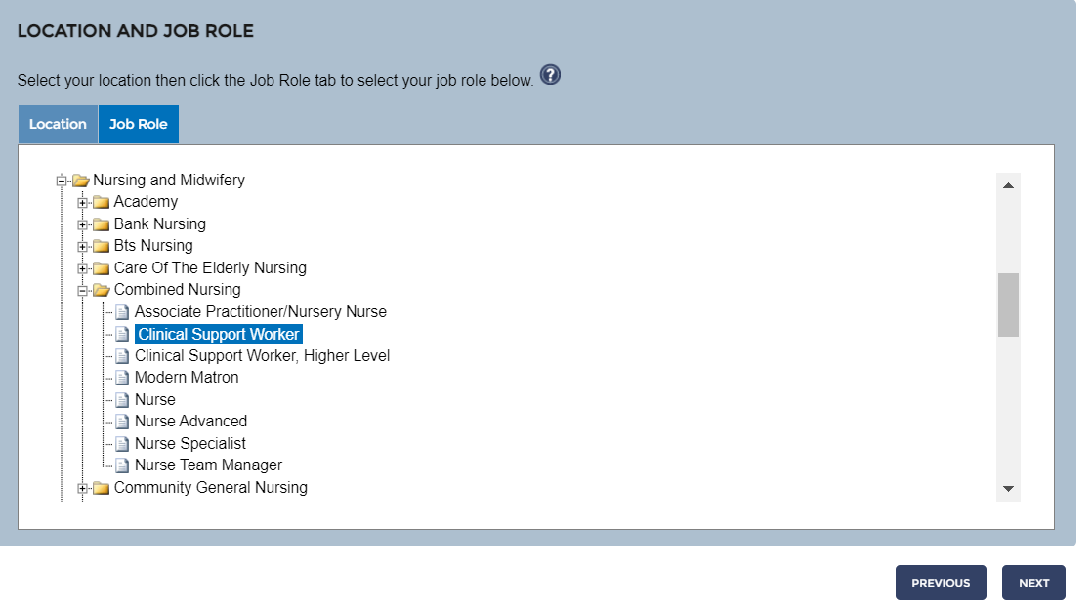

Scroll down the page to find your job role

For example:

* Click on **Nursing and Midwifery**
* Click on **Combined Nursing**
* Click on **Nurse**

You have successfully selected your job role when the text is highlighted in blue.

If you are unable to find job role, please select **Not Known**

Click on the **NEXT** button.

Add your **LearnPro ID Number** which starts with an **X** and followed by 5 digits.

Your **LearnPro ID number** is included in your Induction Instructions email.

Click on **FINISH** button

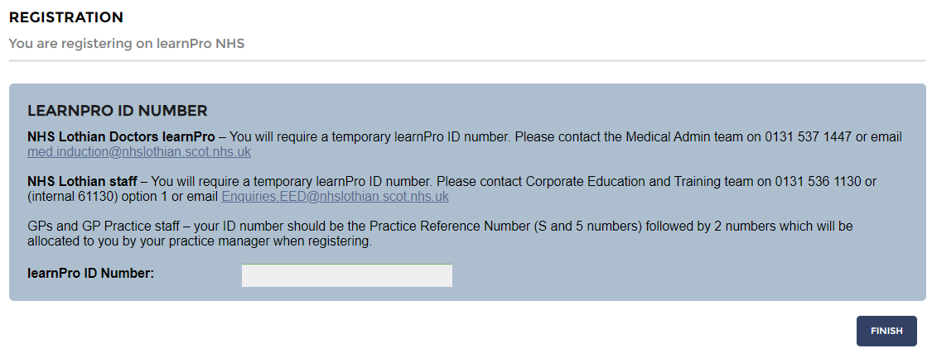

You have completed your registration on LearnPro NHS.

To continue, click **on LOGIN TO ACCESS THE LEARNING MATERIALS** button. This will take you to the LearnPro NHS Login page

