TURAS Learn – Aligning NHS Lothian eLearning

Important: If you already have an existing TURAS account used for any applications, including Learn, Appraisal, or Professional Portfolio, do not create a new account. Instead, log in with your existing credentials, and the Learn application will be available.

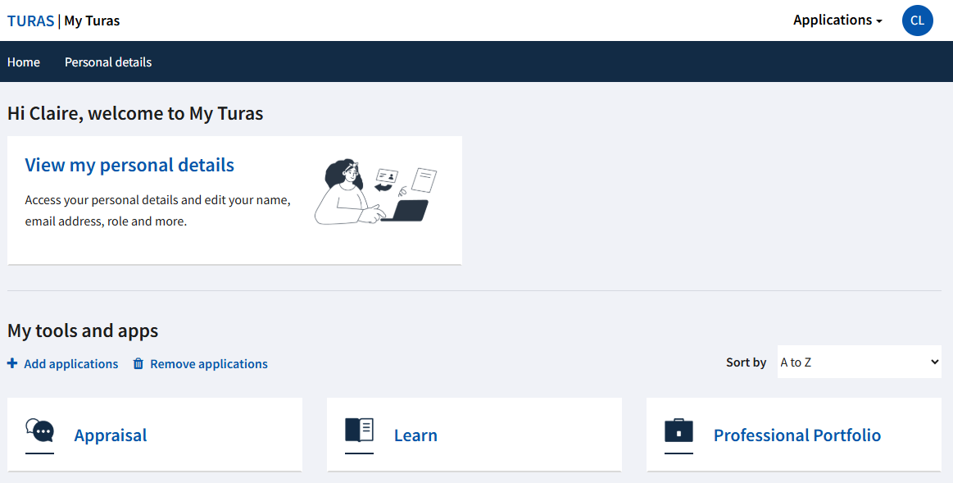

- To access NHS Lothian eLearning, you must update your personal details. You can do this by either:

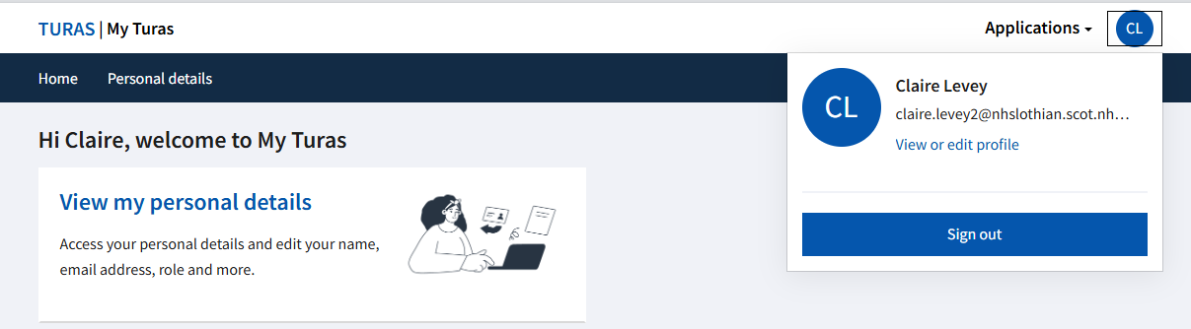
Clicking ‘View my personal details’

Or selecting your profile and clicking ‘View or edit profile’.

- Please update your role details as outlined below.

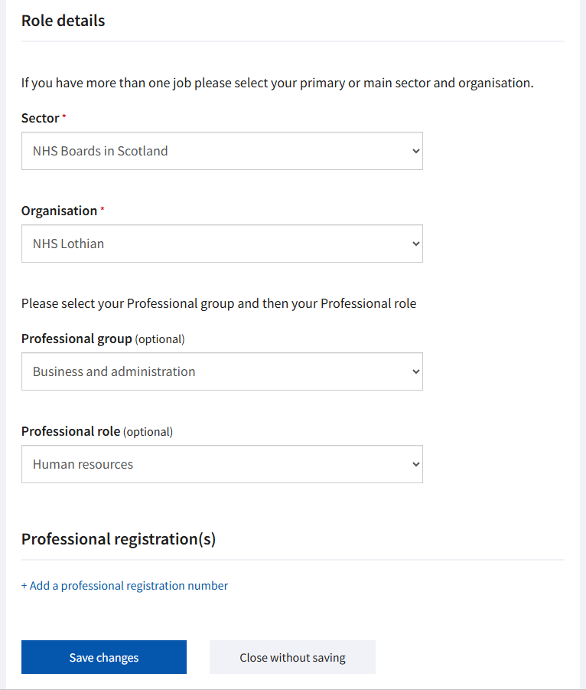
You also have the option to add your professional registration number if desired.
Please select the professional group and role that best aligns with your job responsibilities and service area.
Sector - Please select ‘NHS Boards in Scotland’
Organisation – Please select ‘NHS Lothian’

- Please log out and then log back in for the update to take effect.

- Click on the ‘Learn’ application tile. To access NHS Lothian’s homepage, go to ‘Recommended’ and select ‘NHS Lothian: All Learning Sites’.

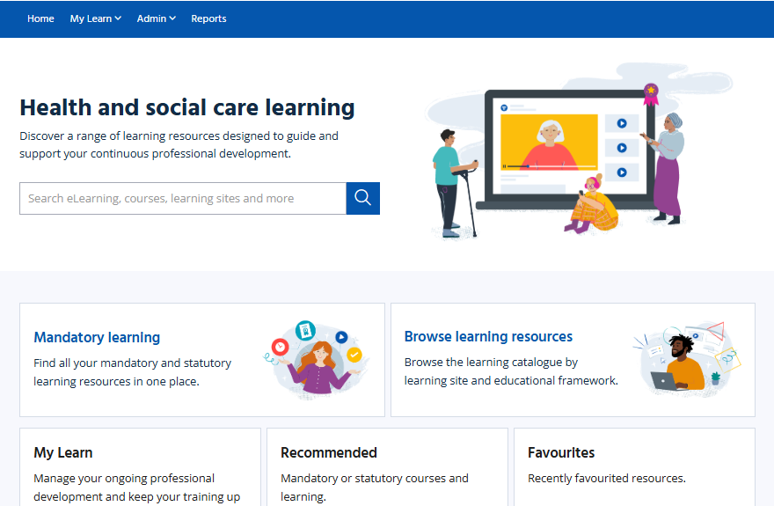

- Please select the appropriate tile for the type of eLearning modules you wish to complete.

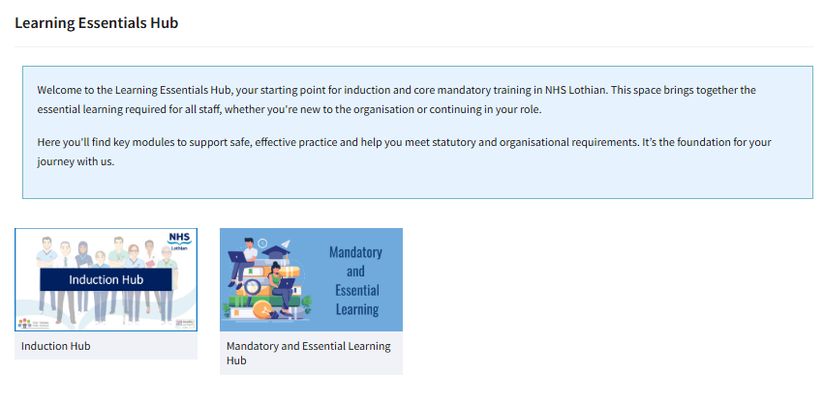
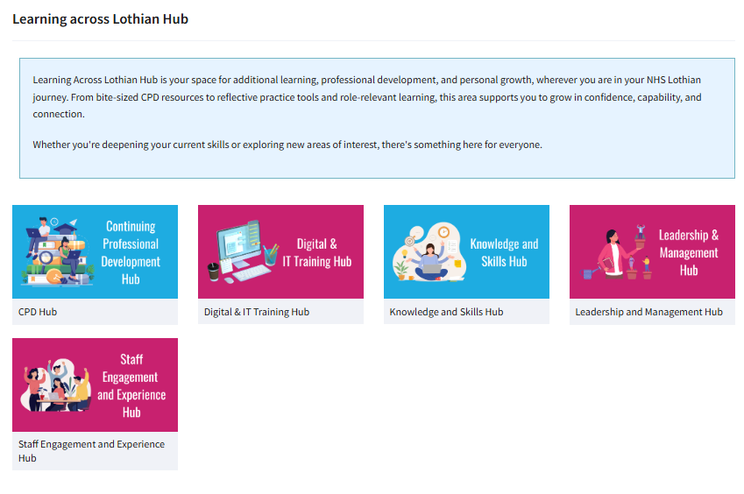

- Core Mandatory Modules can be found under ‘Mandatory and Essential Learning’. This section includes all core mandatory eLearning modules that must be completed by ALL staff working within NHS Lothian.
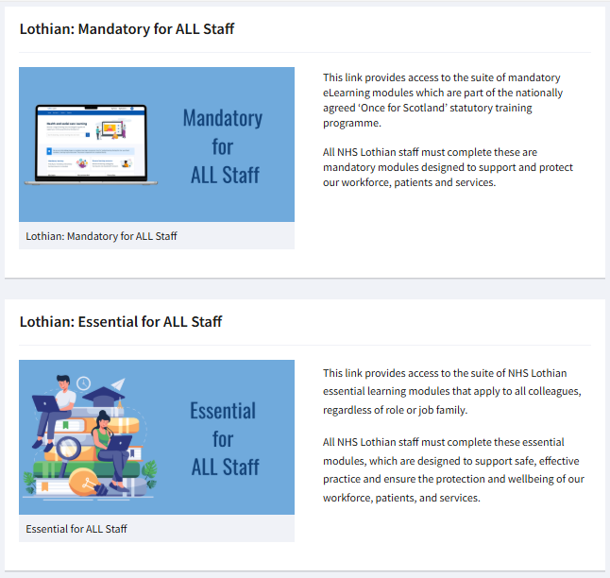

- Click the ‘Launch’ button to start a module


