TURAS Learn – Registering an Account
(For New Users)

Important: If you already have an existing TURAS account used for any applications, including Learn, Appraisal, or Professional Portfolio, do not create a new account. Instead, log in with your existing credentials, and the Learn application will be available.
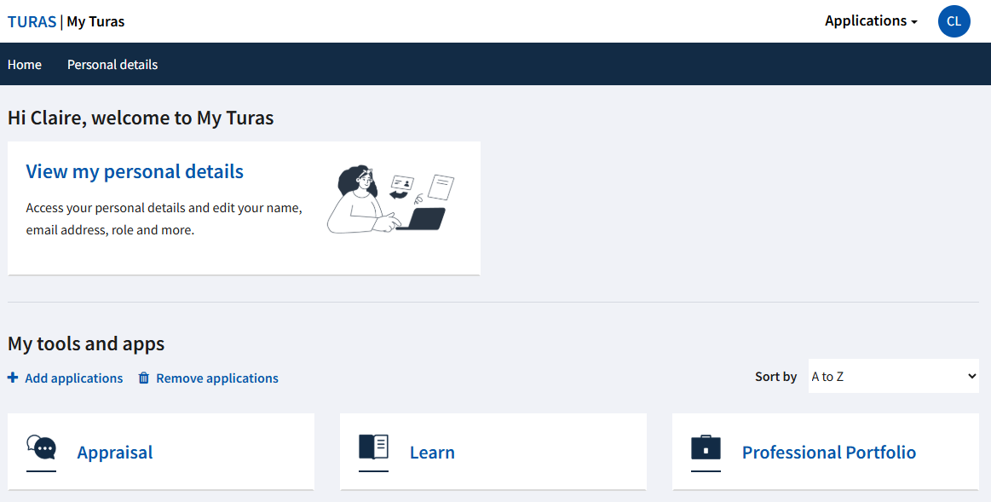

If you are a new user of TURAS please follow the steps below to register an account;

- To Register an account on TURAS visit the home page: learn.nes.nhs.scot
Click the ‘Register’ button at the top right of the screen
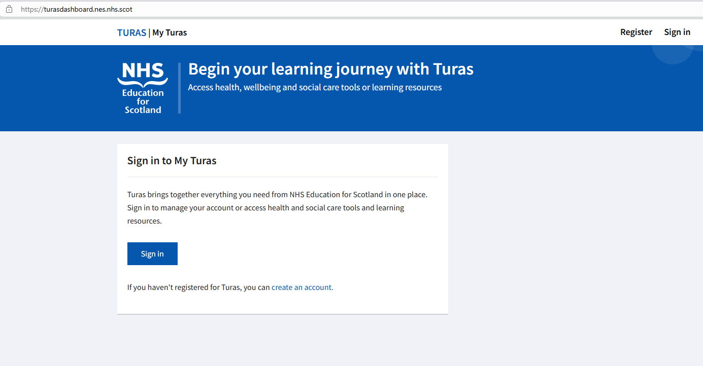

- This will take you to the 'Create your TURAS account’ page
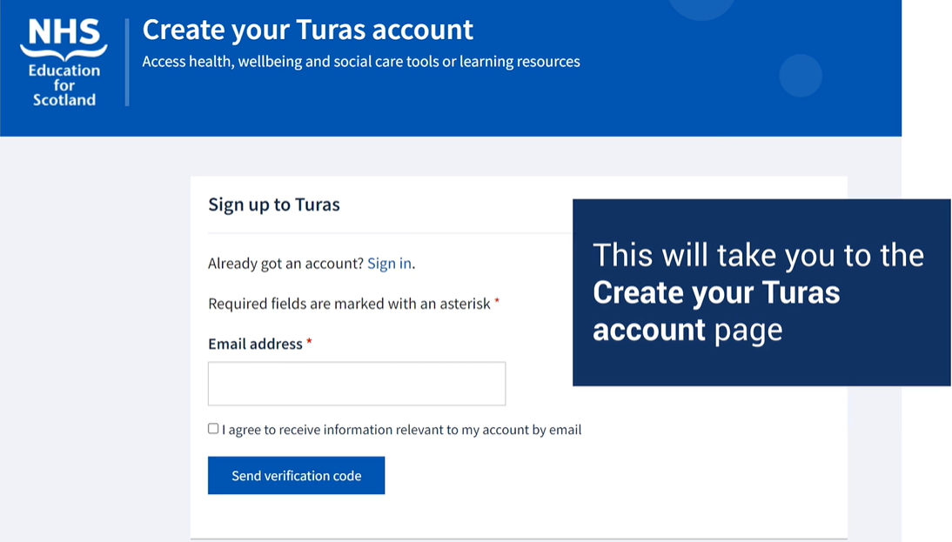
Enter an email address
If you do not have your NHS Lothian email address, please use your personal email address when registering an account for the time being.
- Tick the box next to 'I agree...' to accept the terms and conditions. This must be done to create an account. You will only be contacted with updates about your Turas account
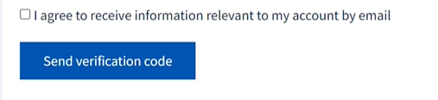
& Click 'Send verification code'.

- This will be sent to your email address.
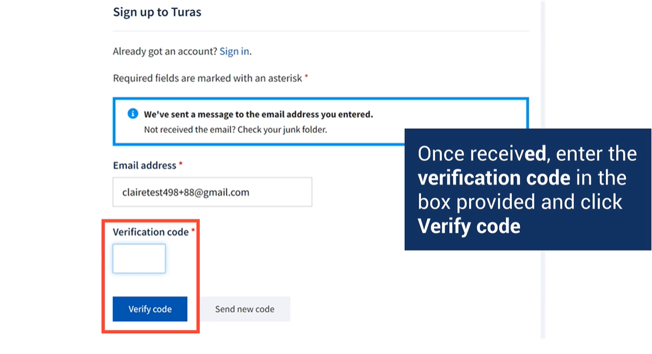
Enter the verification code in the box provided and click 'Verify code'

If verification code has not been received, click 'Send new code'

- When the verification process has been completed, you will see a message to confirm. Click 'Continue'

- You will now be asked to enter your personal and role details

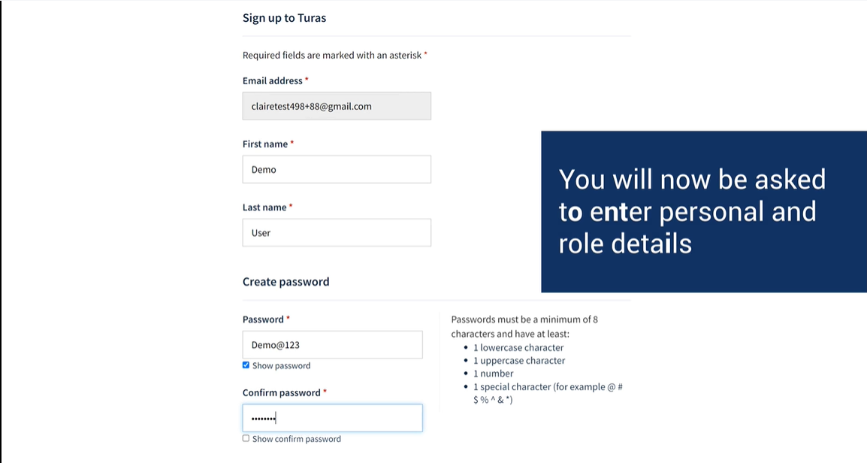
enter your first and last name and create a password

- Complete the rest of the information

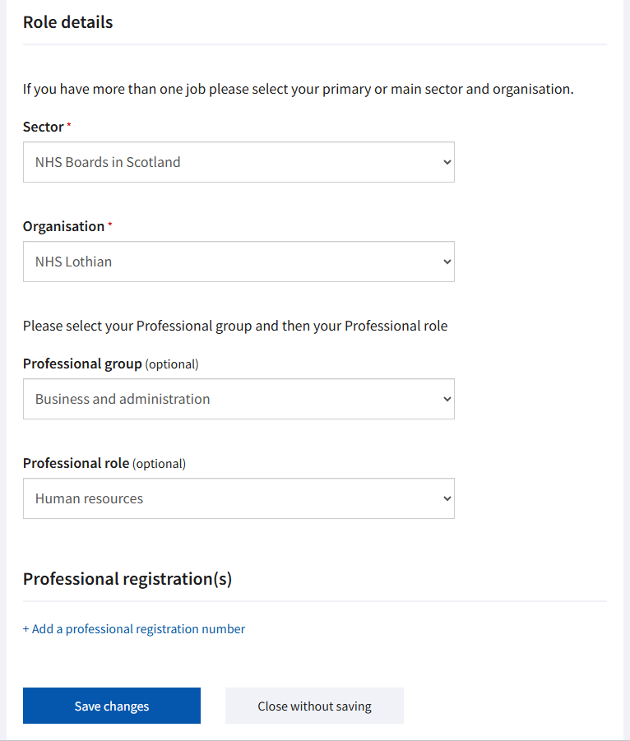
You also have the option to add your professional registration number if desired.
Please select the professional group and role that best aligns with your job responsibilities and service area.
Sector - Please select ‘NHS Boards in Scotland’
Organisation – Please select ‘NHS Lothian’

- Click ‘Create my account’ to complete your registration.

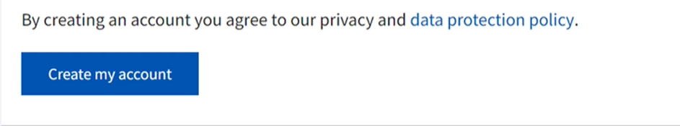

- You can now begin your eLearning. To access NHS Lothian’s homepage, go to ‘Recommended’ and select ‘NHS Lothian: All Learning Sites’.
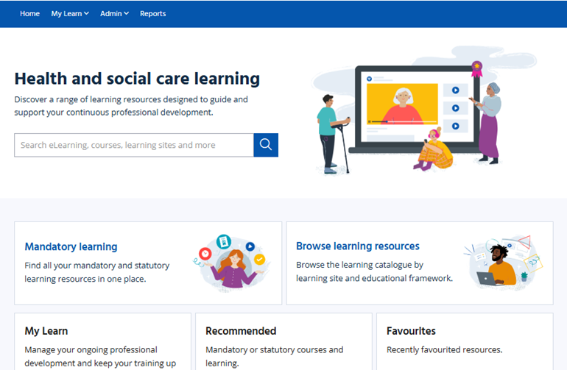

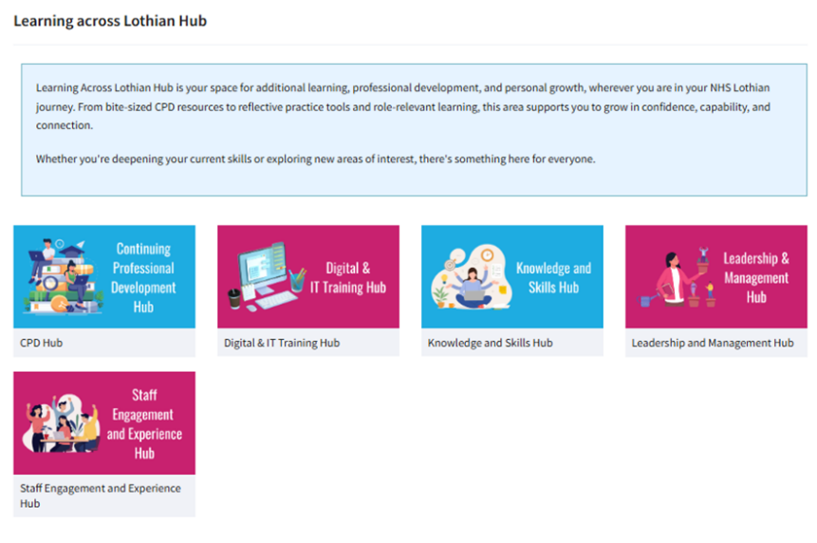
- Please select the appropriate tile for the type of eLearning modules you wish to complete.

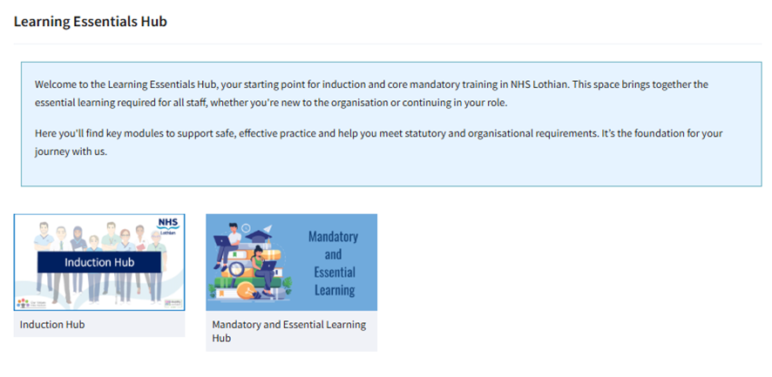
- Core Mandatory Modules can be found under ‘Mandatory and Essential Learning’. This section includes all core mandatory eLearning modules that must be completed by ALL staff working within NHS Lothian.
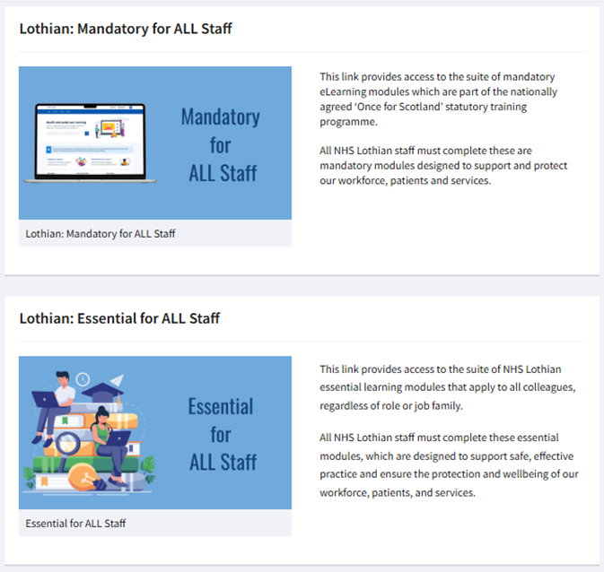

- Click the ‘Launch’ button to start a module


